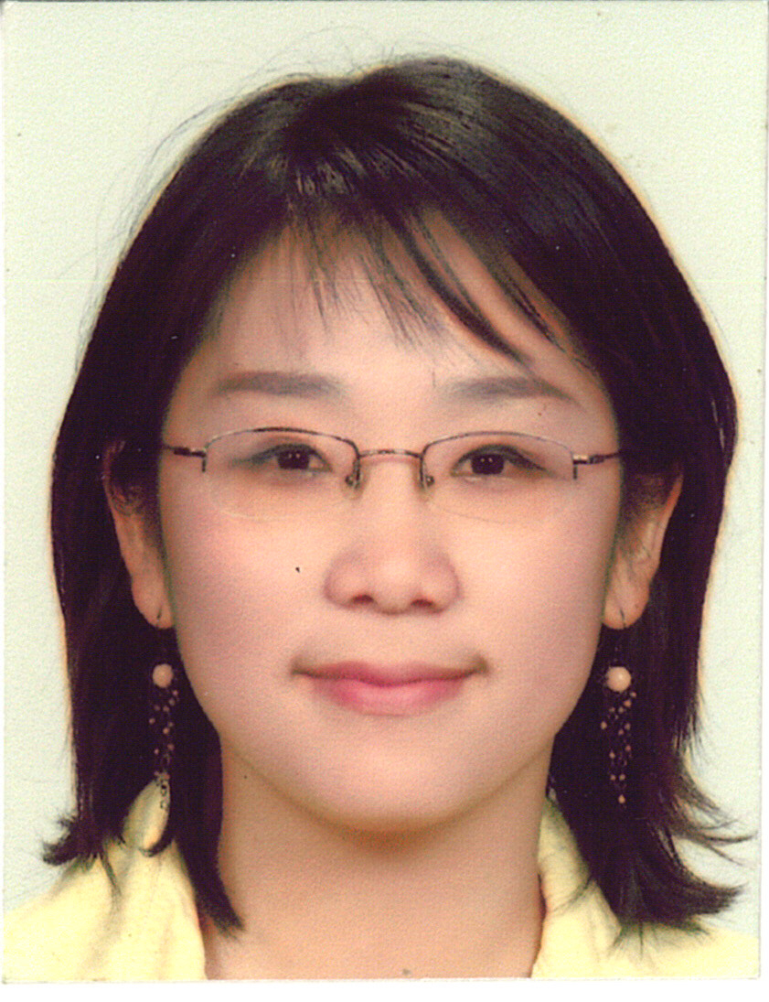

Seung Hee Jung
24 years old

Current Address: 262 Wairau road Glenfield Auckland
Phone: 021 056 3827 ● jshbaby1@hotmail.com

WORK EXPERIENCE

- I have worked at Target Primary school New Zealand assisting with children’s individual needs for three months, and also taught English to international group in ESOL class.

Target Road Primary School
80 Target Road
Glenfield
Auckland 1310
New Zealand Phone: 444-8493

- I have given some private tutoring lessons for Korean students, helping with their English

EDUCATION

Elementary school: Forrest hill New Zealand primary school at the age of eleven.

Secondary school: Westlake Girls High School, Auckland, New Zealand

University: Auckland University of Technology, (AUT) Auckland, New Zealand
Graduated for bachelor degree of English Language Arts in 2010

Any other completed certificate: Interpreting course approved by NZ government

CERTIFICATIONS & TECHNICAL SKILLS

▪ Computer skills – Microsoft Office, Photoshop,
▪ Languages – Excellent fluency in English and Korean (Bilingual)

EXTRACURRICULAR & VOLUNTEER ACTIVITIES

Volunteered for disabled children aid organization
Involved with Korean Student’s Association as an Auckland University speaker and announcer.
Teaching ‘Little Bible ‘group for children at Korean Church

