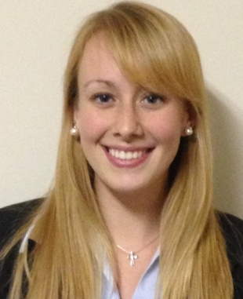

Sara J. Balajthy

EDUCATION: Global TESOL College
Certification for “Teacher of English to Speakers of Other Languages” with emphasis in teaching ESL locally
Graduation: July 2013
State University of New York at Geneseo
Bachelor of Arts, December, 2012
Major: Psychology
Minor: Sociology
GPA: 3.42

HONORS: Psi Chi National Honor Society
Dean’s List
Phi Eta Sigma National Honor Society
St. Lawrence Award for Community Service
WORK
EXPERIENCE: International Justice Mission Jan. 7-April 26 2013
Executive Intern Washington D.C.
- Planned events, assisted in the coordination of programs for over 150 staff
- Organized logistics for the Global Summit, an annual meeting of the Executive Directors of Partner Offices
- Coordinated travel arrangements for members of the Partner Offices and Executive Team
- Performed detail-oriented administrative tasks, took meeting minutes
InterVarsity Christian Fellowship Spring 2013
Administrative Assistant Rochester, NY
- Updated company website by categorizing and reformatting articles
- Wrote summary briefs for over 70 articles
International Justice Mission May 2013
Temporary Constituent Relations Representative Washington D.C.
- Updated database of constituent information on Raiser’s Edge Fundraising and Donor Management Software
LEADERSHIP
EXPERIENCE: Executive Team for InterVarsity Christian Fellowship 2011-2012
- Planned and coordinated events for over 100 people
- Recruited and directed teams to implement planned activities
- Represented InterVarsity at panel discussions and club fairs
Small Group Leader for InterVarsity Christian Fellowship 2010-2011
- Prepared and led discussions with over 20 students
- Developed mentoring relationships with younger students
VOLUNTEER
EXPERIENCE: St. Louis City Lights Service Project, Spring Break 2012
- Worked for Harambe, a community outreach which provides jobs for teenagers in the community through home restoration
- Team leader for fundraising efforts

