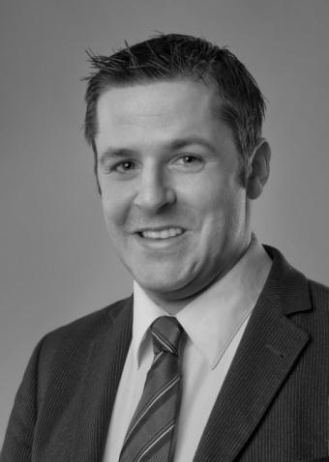
Robert Hyde
010 4443 0815
rogerpun@hanmail.net

PROFILE: | I am a fully-qualified teacher of English as a Foreign Language and an  accredited journalist. From northern Germany I do a mixture of freelance  English language-training and media work at universities, local  companies and to private professionals.  My clients are either my own, subcontracted through other teachers or arranged on behalf of private language schools in Bremen, Hamburg and Frankfurt.

TEACHING WORK: | Freelance teaching work since 2004 has included Business, Academic,  Technical and IT-related English courses to individual professionals and  leading German engineering corporations.  I have also taught Academic, Journalistic and Creative Writing courses for the Practical Language sub-departments of English departments at several German universities. These include, for example, the University of Bremen (2006-ongoing), the Bremen University of Applied Science (2011-ongoing) and the Martin Luther University of Halle-Wittenberg (2004-6).
MEDIA WORK: | Freelance media work since 1997 has featured contributions to a wide range of British newspapers and magazines from The Daily Telegraph and The Lancet medical journal. It has also involved performing voice-overs in corporate films, war documentaties for the award-winning German journalist, Egmont Koch, and talk-shows for Bremen-based organisations such as Center TV.  I have also conducted commissioned research for news wires such as Associated Press Australia and for private individuals such as Poland-based authors specialising in WW2 resistance movements
ENGLISH TEACHING WORK: 2012-13 | Teaching for Aristotle Institut private language school in Bremen. Taught client Buhlmann Tube Solutions. Teaching for Eifert private language school in Frankfurt. Taught client Deutsche Telekom.
2011-ongoing | Business English and General English for aviation company AES and  computer company, IGEL, for John Dennis, English Language  Consultancy, Bremen.
2010-ongoing | Journalistic English, Nursing Science and Energy Technology at Bremen University of Applied Science.
2010-2011 | Teaching Business, IT and New Media English at the Berufsakademie für  IT und Wirtschaft, Oldenburg.
2010-2011 | Teaching advanced writing and conversation courses at the Practical  Language sub-department of the English department at Oldenburg  University, Germany.
2009-onoing | Legal and Business English for a Bremen-based copyright specialist.  Financial English for a Bremen-based German tax specialist.
2006-ongoing | Teaching advanced writing and multimedia courses at the Practical  Language sub-department of the English department at Bremen  University, Germany.
2008-12 | 2008-12. Teaching for Hansa Meyer Global Transport logistics company.
2008-11 | 2008-11. Teaching for private language school Linguarama, Hamburg. Clients include Airbus and Deutsche Post Real Estate.
2006-ongoing | Teaching for Siemens Enterprises, Bremen and British American Tobacco, including sales and administration staff for private language school Language Training Center, Hamburg.
2004-6 | Teaching advanced writing and multimedia courses at the Practical  Language sub-department of the English department at the Martin Luther  University Halle-Wittenberg, Germany.
EDUCATION AND QUALIFICATIONS: 05.2003-  06.2003: | C.E.L.T.A course at Studio Cambridge, Cambridge, England. (Certificate in English Language Teaching to Adults). Qualification is approved and assessed by the University of Cambridge Local Examination Syndicate (UCLES).
09.2002-  02.2003: | Faculty of Education, University of Cambridge PGCE Course. Attended for the stated dates. Referee provided (see ‘Referees’).
10.2000-  01.2001: | London College of Printing. Post Graduate Certificate in Periodical Journalism. Course accredited by the NUJ (National Union of Journalists).
09.1995 –  06.1999: | University of Manchester, B.A. German Studies with French (Grade 2.1). Language, German history, GDR politics and literature, German poetry, medieval German, Kleist, Sturm und Drang, ETA Hoffmann.
09.1993 –  06.1995: | Bishop Walsh RC School, Sutton Coldfield, West Midlands, A-levels in German (A), French (A), English Literature (A).

