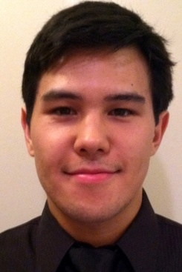r
Richard Chung
Objective:
I wish to obtain employment with an English program that will allow me to
expand my experience already gained and help me continue to shape my
teaching skills necessary for this profession.

Education:
• B.A. in Linguistics, University of Oregon, 2011
• Certificate in Second Language Acquisition and Teaching, University of Oregon, 2011
• TESOL/TEFL Certificate, Global Leadership College, 2013

Work Experience:

Teacher
Maple Bear Global Schools ( 03/12-06/13)
Teaching English, Math & Science to kindergarten aged children

English Tutor
American English Institute -University of Oregon (3/10-6/11)
Private tutoring with ESL university students,aiding teachers

Member Service Representative
Pentagon Federal Credit Union (6/11-3/12)
Helping members with accounts, credit cards, loans,and doing sales

Volunteer Work:

LiNK (Liberty in North Korea)-UO Chapter (05/09-06/11)
Fundraising, preparing events, public speaking/presenting

Ekklesia Children’s Ministry (9/10-01/12)
Aid, instruct and overlook children in bible school

*References obtained upon request

