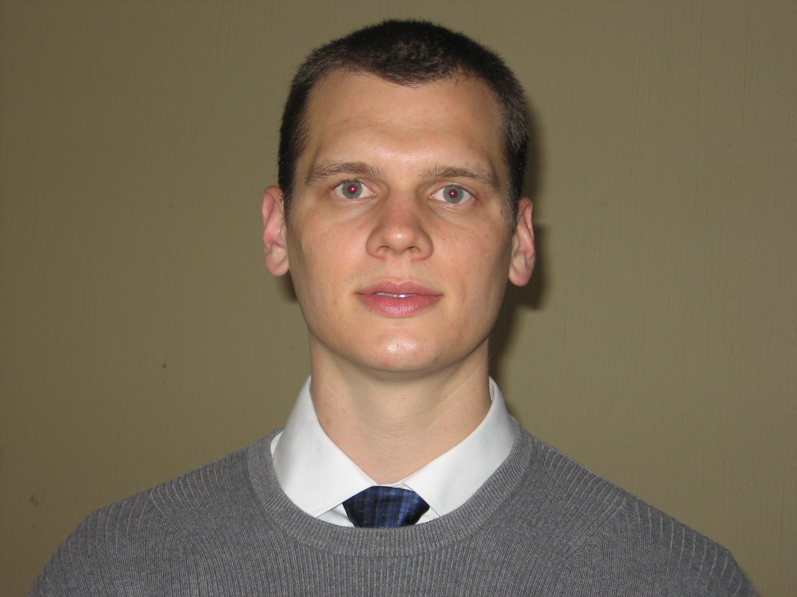David Ferguson

Galeanas 1730-A
Col. La Casita, Zapopan, Mexico C.P. 45138
Cel: (011 52 1) 33 14 51 04 82
Djferg83@hotmail.com

OBJECTIVE
I am seeking a full time English teacher position in South Korea.
EXPERIENCE AND QUALIFICATIONS
-Experience with small groups of 1-25 students in classroom, conversation, and activity settings
-TEFL/TESOL certified
-Experience teaching children and adults
-Taught TOEFL/TOEIC exam preparation courses and several business courses
-Punctual, professional, and hard-working
-Trained, supervised, and managed groups ranging from 3 to 10 employees
EMPLOYMENT

English Instructor 2011
Linguas Centro de Idiomas

-Personalized courses for one-on-one instruction
-Taught TOEFL exam preparation courses.
-Off-site course in Corporate setting
English Instructor 2010
Berlitz Learning Center

-Completed teacher training program.
-Named Instructor of the Month for August
-Taught Business English and Business Idioms programs.
-Utilized both Berlitz and non-Berlitz materials.

English Teacher 2008-2010
Inglés Individual

-Tutored students in individual and group sessions.
-Led TOEFL exam preparation courses.
-Led group Conversation Clubs.
-Taught off-site English course to government employees.

Receiving Supervisor 2006-2007
Macy’s Northwest

-Hired, trained, and managed receiving team associates in fast paced retail environment.
-Worked closely with Merchandise Managers, Store Manager, and Sales Managers to ensure timely placement of products to the sales floor.
-Utilized a variety of computer applications for budget tracking, staff scheduling, logistics coordinating with distribution center, and workload analysis.

EDUCATION
TEFL/TESOL Certification 2010
ITTO Guadalajara

-Completed with Distinction

Central Washington University 2002-2006
Ellensburg, Washington
-B.S. Business Administration
-Specialization: Management & Organization
-GPA: 3.6

