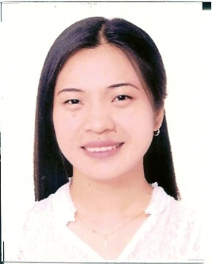
Pamela Rose B. Flores

Phase 10 B Package 6 Block 90 Lot 2
Acco Homes Bagong Silang Caloocan City
Mobile No. 0908-970-1102
E-mail Add: xeandice_f16@yahoo.com

Objectives:
To further enhance my interpersonal and communication skills through dealing with other levels of people.
To develop more my self-confidence by sharing varieties of ideas, also to enrich my knowledge through gathering information with this working experience.

P E R S O N A L I N F O R M A T I O N:

Age: 23 yrs. old
Birthdate: April 10, 1986
Place of birth: Roxas, City
Height: 5’2
Weight: 110 lbs.
Religion: Roman Catholic
Citizenship: Filipino
Marital status: Single
Father’s name: Primitivo E. Flores
Mother’s name: Rosalia B. Flores
Language/dialect spoken: Fluent in English, and can speak basics of Japanese, Korean, and French.

E D U C A T I O N A L A T T A I N M E N T:

Tertiary: Year Attended:

Lyceum of the Philippines University. 2003-2007

Secondary:

Del Rey School Camarin Caloocan City. 1999-2003

Course: B.S. Foreign Service Major in International Trade
Special Skills: Familiarity in MS-Word, MS-Office and Internet Applications.
able to multi-task, strong interpersonal skill, and can handle
pressure.

On-the-job training:

Lyceum Alumni Association Inc.
Muralla St. Intramuros, Manila.

Attended Seminars:

The Philippine Summit on European Studies 2006
Held on January 28, 2006 at the University of the Philippines Diliman.
Diosdado Macapagal Conferenence Hall.
A Career Orientation and Foreign Service Seminar
Held on February 11, 2006 at the University of the Philippines Diliman.
Vidal Tan Hall.
Lecture- Forum on the European Union as a Global Player
Held on February 15, 2006 at the Lyceum of the Philippines University.
Jose P. Laurel Hall of Freedom

Work Experience:

Position Date Address

Technical Support May 5, 09 Robinsons Place-Novaliches Representative July 23,09 Quirino Highway corner
Maligaya Road Novaliches
Quezon City 1123

Online- English Teacher May 15, 08 12A Strata 2000 BLDG.
(for Koreans) Feb. 28, 09. Emerald Ave. Ortigas
Center Pasig City
Philippines

English Instructor Associate Dec.-19-07 to JJ Language Center Inc.
April.- 24-08 3rd flr. Jocfer Building
Diliman Quezon City.
Philippines.

Availabilty: Can start work immediately.

