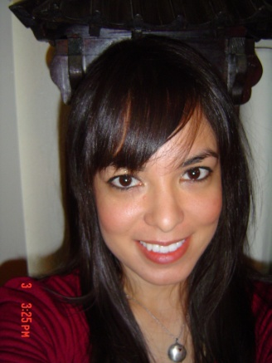

Nina Atwood
28760 Maltby Ave.
Moreno Valley, CA, 92555
Mobile Phone: 010-3040-4259
Email:Dmind81@aol.com
OBJECTIVE

To obtain a position which will utilize my skills and experience, and allow me to advance through new challenges and responsibilities.

QUALIFICATIONS
Two years in customer service. Practice and promote strong work ethics of punctuality, reliability, and responsibility. Capability to work in team environment or independently. Open to new experiences. Flexible. Competent in basic computer skills: Windows, Microsoft Word, Microsoft Excel, Internet etc. Efficient in typing: 60+ wpm. Quick Learner.
EDUCATION
University of California-Riverside
B.A. English 12/2003
WORK EXPERIENCE

-SLI
Seoul, Korea
English Teacher
02/10-01/11

-Woosuk University
Jeonju, Korea
Winter Camp English Teacher
12/09-02/10

-Phillips Edu
Mapo, Seoul, Korea
English Teacher
02/09-08/09
-YBM ECC
Ilsan, Korea
English Teacher
07/2007-07/2008

-Downtowne Bookstore
Riverside, CA
Assistant Manager
09/2004-05/2005
-Riverside Public Library (Main Branch)
Riverside, CA
Library Page
12/2003-10/2005
VOLUNTEER WORK
-Dr. Herman H. Stone Patients' Information Library
Riverside, CA
10/2003-Present
-Friends of the Riverside Library Book Sale Division
Riverside, CA
02/2004-08/2004
TRAINING/CERTIFICATE
-Basic Hands-On Book Repair for Libraries-2004
Given by the Infopeople Project
Instructor Margit Smith
Certificate dated June 14, 2004.
COMPUTER SKILLS
-Basic Computer Skills, Typing 60+ wpm, Windows, Microsoft Word, Microsoft Works, Microsoft Excel, Innovative Millennium, Internet.
REFERENCES
Furnished Upon Request

