Matthew J.E. Roberts
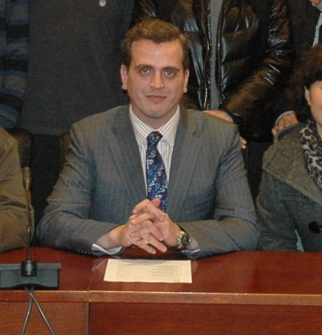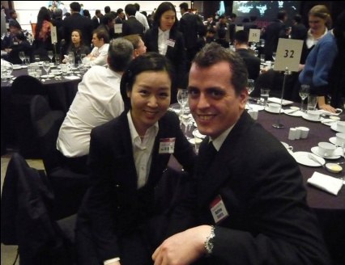
DOB: 19/11/1977, Britain
Skype: mattrob1911
Mobile: 010-2997-1977
mattrob1911@yahoo.co.uk
Professional Profile
A personable, well dressed professional teacher, 35 (1977) and British. I have worked as an ESL tutor for over 7 years, I have taught all ages and levels in Italy, China and mostly Seoul.

I am always well presented and punctual; I plan my lessons carefully and take great pride in my work and its results.
Qualification
2000 – 2003:
Media Production (BA HONS). University of Cumbria, Carlisle.

2005:
TEFL Certificate (Teaching English as a Foreign Language). i-to-i, Leeds.

ESL Career Summary.
2006 – 2010:
Senior Foreign Teacher. YBM ECC (’06 – ’08), DOCS Academy (’08 – ’10), Nowon-Gu, Seoul, KOREA.
- Planned lessons, and taught children from 5-13 years old.
- Managed 5-6 foreign teachers; instructed them on what to do and dealt with any problems they had with housing or work.
- Had meetings with Korean managers, passed on relevant information between the managers and foreign staff. Proof read new text books.

2010 – 2011:
Language Tutor. Pagoda, Guro Digital Complex, Seoul, Korea.
- Planned and taught conversation classes.

2011-2012:
Corporate Language Trainer. English First, Hangzhou, China.
- Planned and conducted business lessons.
- Was responsible for gaining and securing 3-6 month tutoring contracts from companies.

2012 – Present:
Language Tutor. Pagoda, Gangnam, Seoul, Korea.
- Planned and taught conversation and business classes.

Hobbies/Interests
My hobbies and interests lie in menswear, hiking, the gym, travel, reading and current affairs.

Referees
David Rothenburg,
Pagoda, 8th Floor, Pagoda Tower, Gangnam, Seoul, Korea.
010-4080-3213

Simon Kwon,
ceo@edocs.co.kr
DOCS Academy, 8th Floor Kwansangbokhapchungsa, 665 Shinnae – 2 Dong,
Jungrang-Gu, SEOUL, KOREA.
02-3422-0515

James Choles,
jamesefhz@gmail.com
English First, Hangzhou, CHINA.

