Marlon Oreiro
______________________________________________________
E-Mail/Skype: marlon.oreiro@outlook.com
Phone: +1 (415) 548-3587

April 01, 2017
RE: #2. Language school, Suwon.
Dear Russell,
I read with interest your posting for Foreign English Teacher on www.worknplay.co.kr job site. I believe I possess the necessary skills, experience and qualifications you are seeking and would make a valuable addition to your company.
As my resume indicates, I possess more than three years of progressive experience in the clerical job field in the United States. My professional history includes positions such as Postal Support Employee (PSE) with the United States Postal Service (USPS) as well as an owner of my own company.
Most recently, my responsibilities as a Foreign English Teacher at International Language School (Geoje) (Nov2016 to Feb2017) match the qualifications you are seeking. As an English Teacher, my responsibilities included classroom management, lesson planning, and maintaining scholastic standards.
I gained this experience as a substitute for the main Foreign English Teacher and successfully completed my three-month contract. The director relied on my ability and qualification to take over all the job and responsibilities of the main Foreign English Teacher.
I have attached my resume for your review and I look forward to speaking with you further regarding your available position.
If accepted, I am currently in Korea thus saving your company the airfare and I am available for an interview either face-to-face or on Skype.
Current Address:
신정중앙로 21길 34 근상프리즘
서울특별시, 양천구 158-070
South Korea

Sincerely,
Marlon Oreiro
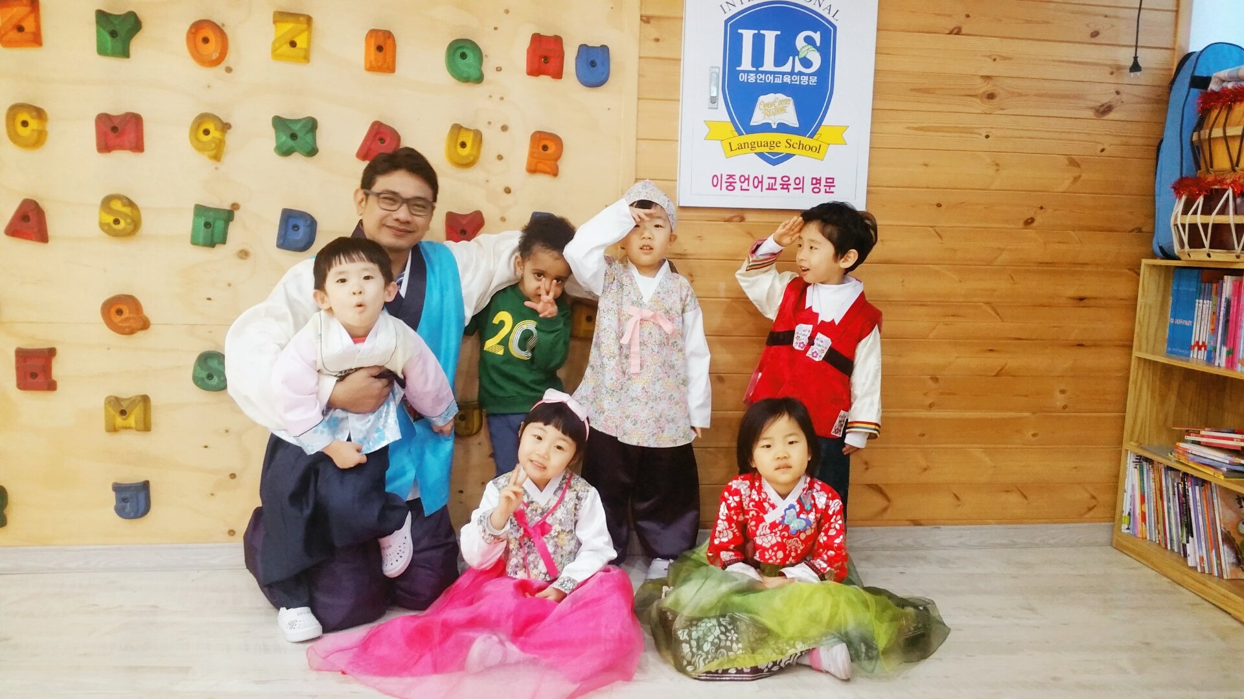
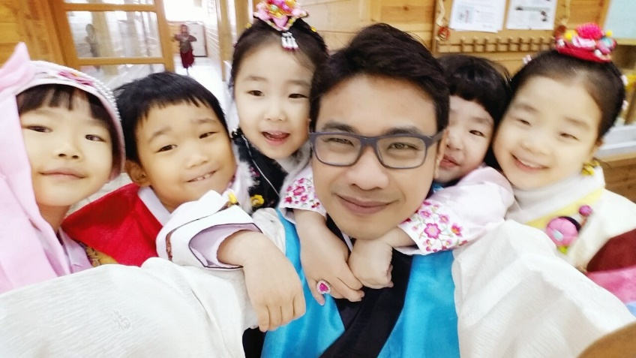

As a Foreign English Teacher in Geoje International Language School (ILS).

NAME IN PASSPORT
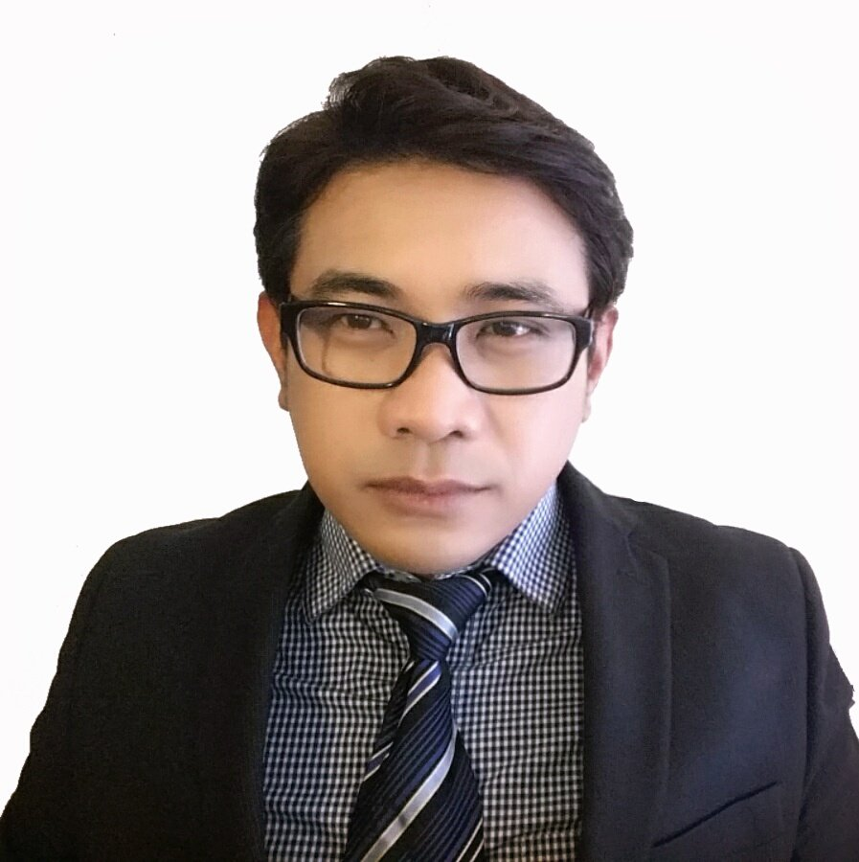
O | R | E | I | R | O
SURNAME
M | A | R | L | O | N
GIVEN NAME (FIRST AND MIDDLE)

DATE OF BIRTH AGE
1 | 9 | 7 | 9 |  | 0 | 3 |  | 1 | 2 |  | 3 | 8
YEAR |  |  |  |  | MONTH |  |  | DATE

GENDER MARRIAGE PLACE OF BIRTH
X |  |  |  |  |  | X |  | CAVITE | PHILIPPINES
MALE |  | FEMALE |  | MARRIED |  | UNMARRIED |  | CITY (STATE/PROVINCE) | COUNTRY

PRIMARY CITIZENSHIP SECONDARY CITIZENSHIP
UNITED STATES OF AMERICA
CITIZENSHIP YOU WOULD USE TO TEACH IN KOREA |  | LIST ANY OTHER CITIZENSHIP(S) YOU HOLD

KOREAN HERITAGE (IF APPLICABLE) | YES | NO
- Are you ethnically Korean? |  | X

 | YES | NO
- Does the Korean government consider you to be a holder of Korean citizenship? You MUST consult the Korean Embassy/Consulate about your nationality status BEFORE applying. |  | X

INTERVIEW CONTACT INFORMATION
Available interview time frame** | ANY TIME | Skype ID | marlon.oreiro@outlook.com
Primary Phone | +1 (415) 548-3587 | City & Country | SAN FRANCISCO USA
Secondary Phone | +1 (831) 442-8959 | City & Country | SALINAS USA
Primary Email | marlon.oreiro@outlook.com | Secondary Email | orei3632@gmail.com

CURRENT AND PREVIOUS RESIDENCE(S)
CITY and STATE / PROVINCE |  | COUNTRY | FROM (MM/YY) | TO (MM/YY) | YEAR(S) |  |  | MONTH(S)
CURRENT | SALINAS, CALIFORNIA | USA | 08/1992 |  |  | 23 | 9
PREVIOUS

MAILING ADDRESS
1845 DELANCEY DRIVE | SALINAS | CA | 93906 | USA
HOUSE NUMBER & STREET NAME | CITY | STATE/PROVINCE | POSTAL CODE | COUNTRY
+1 (831) 442-8959
TELEPHONE (INCL. COUNTRY CODE & AREA CODE)

EMERGENCY CONTACT
FREDELLEN | LO |  | SISTER | fredellen17@yahoo.com
FIRST NAME | LAST NAME |  | RELATIONSHIP TO YOU | EMAIL
+1 (408) 531-1012 |  | +1 (831) 207-7253
HOME PHONE (INCL. COUNTRY CODE & AREA CODE) |  | MOBILE PHONE (INCL. COUNTRY CODE & AREA CODE)

EDUCATIONAL BACKGROUND
LEVEL | NAME OF INSTITUTION | STATE/ PROVINCE & COUNTRY | ENROLLMENT |  | GRADUATION DATE (MM/YY) |  | NUMBER OF YEARS AT SCHOOL
 |  |  | FROM  (MM/YY) | TO  (MM/YY)
ELEMENTARY | GALONGEN ELEMENTARY SCHOOL | LA UNION, PHILIPPINES | 08/1986 | 06/1992 |  |  | 6
MIDDLE | WASHINGTON MIDDLE SCHOOL | CALIFORNIA, USA | 08/1992 | 06/1994 |  |  | 2
HIGH | SALINAS HIGH SCHOOL | CALIFORNIA, USA | 08/1994 | 06/1998 |  |  | 4
POST  SECONDARY  EDUCATION (1) | HARTNELL COLLEGE | CALIFORNIA, USA | 08/1998 | 06/2000 | MM/YY |  | 2
 | DEGREE: ASSOCIATE OF ARTS | MAJOR: GENERAL STUDIES |  |  | Overall Grade: 2.8
 |  | If you do not have your diploma, when will you receive it? |  |  |  | MM/DD/YY
POST  SECONDARY EDUCATION (2) | CALIFORNIA STATE UNIVERSITY MONTEREY BAY | CALIFORNIA, USA | 08/2007 | 12/2010 | 06/2011 |  | 2
 | DEGREE: BACHELORS OF ARTS | MAJOR: GLOBAL STUDIES |  |  | Overall Grade: 2.8
 |  | If you do not have your diploma, when will you receive it? |  |  |  | MM/DD/YY

ENGLISH TEACHING CERTIFICATION/ VALID TEACHING CERTIFICATION
TITLE OF CERTIFICATION | Program Name
TEFL / TESOL / CELT / CELTA | OXFORD SEMINARS | Issue Date | Hours  In-class | Hours Online
 |  | 11/2014 | 100
Valid Teaching Cert / License / Credentials |  | Issue Date | Expiration Date
 |  | MM/YY | MM/YY

CURRENT EMPLOYMENT
JOB TITLE | EMPLOYER | STATE / PROVINCE & COUNTRY | FROM  (MM/YY) | TO  (MM/YY) | NUMBER OF MONTHS |  |  |  | FULL-TIME OR PART-TIME
 |  |  | MM/YY | MM/YY
IF THIS JOB IS A CONTRACT TEACHING POSITION, WHAT IS THE FINISH DATE OF THE CONTRACT? |  |  |  |  | M | M | D | D | Y | Y | Y | Y

TEACHING EXPERIENCE IN THE UNITED STATES
NAME OF INSTITUTION | POSITION TITLE | FULL / PART TIME | SUBJECT | STATE / PROVINCE & COUNTRY | AGE RANGE OF STUDENTS | FROM  (MM/YY) | TO  (MM/YY) | NUMBER OF MONTHS
CALIFORNIA STATE UNIVERSITY MONTEREY BAY | TEACHER ASSISTANT (TA) | PART TIME | GLOBAL ECONOMY | CALIFORNIA, USA | 21 TO 35 | 08/2009 | 12/2009 | 4

TEACHING EXPERIENCE IN KOREA
NAME OF INSTITUTION | NAME OF MAIN  DIRECTOR | OFFICE PHONE | EMAIL
International Language School (ILS) | Joanne Gim (김지언) | 638 0535 | teardrop1211@naver.com

NON-TEACHING WORK EXPERIENCE Exclude information listed in Section 9-1. Add more rows if necessary.
JOB TITLE | EMPLOYER | STATE / PROVINCE & COUNTRY | FROM  (MM/YY) | TO  (MM/YY) | NUMBER OF MONTHS | FULL-TIME OR PART-TIME
POSTAL SUPPORT EMPLOYEE (PSE) | UNITED STATES POSTAL SERVICE (USPS) | CALIFORNIA, USA | 02/2012 | 02/2016 | 48 | FULL-TIME
OWNER | HAGDANAN ENTERPRISES | CALIFORNIA, USA | 12/2005 | 12/2007 | 24 | FULL-TIME
PART-TIME FLEXIBLE CLERK (PTF) | UNITED STATES POSTAL SERVICE (USPS) | CALIFORNIA, USA | 05/2005 | 12/2005 | 5 | PART-TIME

ADDITIONAL PERSONAL INFORMATION
 | YES | NO | IF YES, PLEASE EXPLAIN
- Was English the language of instruction from at least 7th grade through university and were these schools located in one of the seven designated countries we hire from or an international school? | X
- Have you broken any teaching contract, whether at home or abroad? |  | X
- Besides earlobe piercings, do you have any other piercings or tattoos? (Be specific. For tattoos, please indicate size and location) For tattoos located in the following locations, a photo of the tattoo(s) must be included with your initial application: behind the ears, neck, wrist, collarbone, arms, hands, fingers, feet, and calves. |  | X
- Have you ever been charged (whether convicted or dismissed) of any offense/crime? (Alcohol or substance-related offenses included) |  | X
- Are you a vegetarian or vegan? |  | X
- For those currently residing in Korea, do you have your own housing in Korea not provided by your current employer and want the housing stipend? If yes, please provide the address. This cannot be changed after submission of the application. If not in Korea, check “No”. |  | X
- Are you applying with any other person (excluding joint applicants)? If yes, please indicate their full legal name and your relationship to them. NOTE: We cannot guarantee placement in the same province or metropolitan city. |  | X

SELF MEDICAL ASSESSMENT
QUESTION |  |  | YES | NO | IF YES, PLEASE EXPLAIN
- If necessary, are you prepared to undergo physical tests to verify the answers given in the Self Medical Assessment? |  |  | X
- Do you have or have you ever had any of the following: |  |  |  |  | ASTHMA INHALERS
- Allergies, High Blood Pressure, Diabetes, or Hepatitis |  |  |  | X
- Do you currently have or ever had any infectious disease that threatened public health before (such as, but not limited to: Cholera, Tuberculosis, etc)? |  |  |  | X
- Have you ever suffered from, or been treated for, depression, anxiety, or any other mental or mood disorder? (If you have received treatment, please explain and attach a medical report). |  |  |  | X
- Have you ever abused or been addicted to alcohol, any narcotic, stimulant, hallucinogenic or other substance (whether legal or prohibited)? |  |  |  | X
- Are you taking any prescribed medication? |  |  | X
- Do you have any cognitive or mental disabilities? |  |  |  | X
- Do you have any visual or hearing impairment (excluding those that are easily corrected with glasses or contacts) or any physical disability? |  |  |  | X
- Have you had any serious injury or sickness in the last five years? |  |  |  | X
- Medically speaking, do you have any dietary restrictions? |  |  |  | X
- Do you smoke? (If yes, no explanation in right column needed) |  |  |  | X
- How many alcoholic beverages do you drink a week? |  |  |  |  | 3
HEIGHT IN CENTIMETERS  (round to the nearest whole number): | 168 cm | WEIGHT IN KILOGRAMS  (round to the nearest whole number): |  |  | 72 kg
1 in = 2.54 cm 1 lb = 0.45 kg

CONSENT FOR VERIFICATION, DATA STORAGE, AND STATEMENT OF TRUTH

MARLON | P | OREIRO
FIRST NAME | MIDDLE INITIAL | LAST NAME
 |  | 04 | / | 01 | / | 2017
SIGNATURE (DIGITAL APPLICANTS MUST TYPE HERE AND SUBMIT INK SIGNATURES LATER) |  | DATE

PERSONAL ESSAYS

Why do you want to teach EFL in Korea?
My decision to teach EFL in Korea started with my passion to help my Korean friends here in the US. I understood my friend’s frustration and difficulty, and I would like to be someone who could help them. I would like to learn, gain the experience, and develop my skills as an English teacher, so that I could be much more effective in helping my students and my Korean friends. I believe that preparing them to face an English environment could be a valuable lesson that I could offer, and being able to make a difference in their lives has encouraged me to teach EFL in Korea.

I’ve also decided to teach in Korea since I would like to learn more about its culture, language, and meet friends. It has always been my life’s goal to become a US Foreign Service Officer, and I believe that teaching English in Korea would be a valuable experience towards that goal. Working and living in Korea would give me the opportunity to learn the Korean language and to become fluent with it. To be immersed in its culture would give me a much more profound understanding and wisdom about the intricacies of international relations in the region.

I also believe that my passion in Globalization, particularly it’s common medium of communication—the English language, would give my teaching ability a much more profound influence to my students as they prepare to take their place in a globalized world. The prospect of being a positive influence in someone’s life gives me the encouragement to teach EFL in Korea. Thus, I submit my application with the sincerity of someone who is willing to help as well as to educate, and to be a positive contributor to the overall well-being in Korea.

Please explain your teaching philosophy.
Teaching has always been the passion that my mother, who was a school principal, has instilled in my character; as I was inspired by how much she cared about her student’s well-being. My mother believed that a proper education should nurture the future and the potential of every student, and it is the teacher’s responsibility to provide every student this nourishment and guidance. Inevitably, my path to teaching English started out as a hobby, as I helped my foreign friends (particularly interns, travelers, and students from South Korea) with their endeavors here in the United States. My desire to help my friends to succeed has encouraged my passion for teaching English.

Although English was not my first spoken language I have been living in the United States for over twenty-three years, and have acquired an advanced education and fluency with the English language. I believe that I have a distinct advantage when it comes to teaching English as a second-language, because of my first-hand experience in learning and developing my English proficiency and fluency over the course of many years. English has become my primary language (L1) with a native-speaker’s fluency and mastery, and an education in the United States from middle-school through university graduation.

In my own personal account, I've learned that being able to sympathize and identify with an English learner is one of the core virtues in teaching English. My personal experience in learning the English language has enabled me to better understand the path and the struggles that an English learner is going through. By helping friends learn English as they adapt to the lifestyle and culture of the US, I've learned that the teacher must provide direction for the learner, while supporting them through their struggle.

Share your thoughts on encountering cultural differences.
As a Global Studies graduate from California State University Monterey Bay (CSUMB), exposure to various language, culture, religion, world view, and nationality has developed my keen understanding to the importance of communication—particularly with the English language. I learnt that understanding the necessity and the utility of the English language in the real-world could bring all of these variables in a peaceful and harmonious platform toward a common goal in a globalized world.

I guess I could say that I’m an advocate to a much more peaceful and harmonious cultural interaction, with an open mind and tolerance to all of its difference. Because I believe that being open minded and tolerant to cultural differences is the secret ingredient of miracles and genius, and it is also the humane path for humanity. Each culture brings in its virtue and values, and if it is recognized through cultural tolerance and open mindedness, their relationship could develop and evolve into something much greater—as seen as with the cultural diversity in the United States.

Global Studies in CSUMB wasn’t my first major, rather I also majored in Computer Science from San Jose State University (SJSU) in Silicon Valley, California. But after my third year in the program, I decided to start my own business; Hagdanan Enterprises. My business enabled me to travel to China, which has opened my eyes in a much greater world and into the intricacies of cultural encounters. From my experience, I realized the importance of a common language where economy, politics, society, and culture could come together—which is the English language. I was very thankful that I spoke such common language, but I also realized in horror if I didn’t speak it. Because I realized that I would have been hopeless if I couldn’t communicate with my clients and customers.

LESSON PLAN

Grade Level | Check one of the following: |  | Check one of the following:
 | Elementary |  | Beginner
 | Middle |  | Intermediate
 | High |  | Advanced
# of Students | 30
Lesson Topic | Modals and Phrases of Request, Permission, Desire, and Preference
Previous Class | Summary:  - Previously, the students were given a study handout (form 1) to follow along for the lesson Modals of Ability and Possibility, which would be covered in the next three class sessions.  - We discussed about two amazing people. Where the students read a magazine article from the book, Two Amazing People (p.156), and discussed why the people that were featured are so amazing.  - From this article, Modals of Ability: Can and Could; Be Able to were introduced. The students were given examples of can + verb and could + verb; to identify what form of the verb follow can and could, and to recognize the negative forms of can + verb and could + verb.  - The students were then introduced Be Able To as a form that has the same meaning as can and could, which also has a negative form.  - At the end of the class, the students were given an assignment:  - For assignment, the students were given an assignment worksheet (form 2) with three columns for past, present, and future abilities. They are to list their own skills or abilities that they have learned in the past, currently have in the present, and their projected future skills.  Class Outline:  Modals of Ability and Possibility  - Grammar in discourse: Two Amazing People  - Form 1: Modals of Ability: Can and Could; Be Able To  - Can for Present and Future Ability.  - Could for Past Ability  - Be Able To for Past, Present, and Future Ability
Materials/  Additional Handouts | - Text Book: Grammar Sense 2  - Audio: CD1 T47  - Form 1: Three-page study handout  - Form 2: Assignment worksheet
Introduction  (Time:7min) | Class Objectives:  Building upon the previous lesson, Modals of Ability: Can and Could; Be Able To, today’s lesson covers the meaning and use of these modals in Present Ability, Future Ability, and Past Ability. By the end of the class the students would be able to create their own modals of ability sentences, and to distinguish the meaning and use of its past, present, and future form.  - Key Expressions:  - Present Ability with Can  - Future Ability with Be Able To and Can  - Past Ability with Could and Be Able To  - Key Vocabulary:  - Can – Can’t  - Is able to  - Will be able to  - I will – I’ll  - Was/Were able to – Wasn’t/Weren’t able to  - Could – Couldn’t  - Can – Can’t Know how to – Doesn’t know how to  - Class Outline:  - Meaning and Use 1: Past, Present, and Future Ability  - Present Ability with Can  - Future Ability with Be Able To and Can  - Past Ability with Could and Be Able to  - Vocabulary notes: Know How To  Greetings & Review:  Start the class with a light conversation about how their English skills has developed or progressed starting when they just first took an English class.  - Engage about what they have noticed about the development or progress of their English skills.  - Ask about instances what they could do now with their English skills, compared to their skill level before.  - Excite them about the future possibilities that they could do with their English skills.  - Encourage them to make personal steps in how to achieve their goals.
Development  (Time: 30min) | Presentation:  - Write on the board the following sentences and engage the students to evaluate with the questions below.  - Carl can type 40 words a minute.  - Last year Carl could type 20 words a minute.  - When Carl’s typing class ends, he will be able to type 60 words a minute.  - Evaluate which sentence talks about an ability that Carl has at the present time?  - Evaluate which sentence talks about an ability Carl doesn’t have yet?  - Evaluate which sentence talks about an ability Carl had in the past?  - Discuss the answers with the class and read the Meaning and Use Notes to check them (p.162 – 163).  - Meaning and Use Notes  - Present Ability with Can  - Future Ability with Be Able To and Can  - Past Ability with Could and Be Able To  - Explain and clarify.  Practice:  On the textbook, study and engage with the following exercises (p.164 – 165):  - Listening for Meaning and Use  - Listen to CD1 T47.  - Listen to each speaker (CD1 T47).  - Choose the correct response (p.164, C1).  - Talking About Future Abilities  - Complete the sentences (p.164, C2) with will/won’t + be able to.  - Distinguishing Between Can and Be Able To  - In the textbook (p.164, C3), rewrite the following sentences with can where possible.  - Talking About Past Abilities  - Working with a partner. Look at the following topics, and think about how people lived fifty years ago. Take turns making sentences with could(n’t) and was/were (not) able to.  education food housing relationships  energy health Leisure time transportation  - Comparing Long Periods of Time and Single Events  - In the student’s notebook, rewrite the following sentences (p.165, C5) with could or couldn’t where possible. Do not change the meaning.  - Look back at the sentences. Which sentences cannot be rewritten? Why?  - Talking About Skills  - Activate what the students has learned with an activity.  - They are to ask their classmates questions to find out who has the skills on the list (p.166, C6).  - Ask four questions with can and four questions with know how to.  - Work in small groups. Talk about their classmates’ abilities. Use can and know how to.  Production:  Based on the following scenarios, act out scenes in which the students demonstrate their understanding of the different modals. The students will be divided into the three groups: Past Ability, Present Ability, and Future Ability. In each scenario, each group is to act out what they could and what they couldn’t do based on the modal form of their group.  - You have a bad cold with aches, congestion, and fever.  - You made two different plans for the same time by mistake.  - Your car is not working and you’re running late to school.
Conclusion  (Time: 13min) | Summary & Closing  - Review today’s lesson.  - Drill on the meaning and use:  - Present Ability with Can  - Future Ability with Be Able To and Can  - Past Ability with Could and Be Able to  - Affirmative and Negative Statements  Evaluation of Objectives:  Practice and evaluate the student’s retention of the subjects from the day’s lesson materials by using their assignment (form 2).  - Ask the students to choose one ability from their assignment worksheet (form 2).  - Write a sentence based on the Modals of Ability: Can and Could; Be Able To, in regards to its past, present, and future forms. In both affirmative and negative statements.  - Give examples.  - Their papers will be given as a take-home pop quiz and to be reviewed on the next class.
Next Class | - For the next class, we will continue the lesson Modals of Ability and Possibility, which would conclude this lesson. This will include the pages 167 to 176 on the text book, Grammar Sense 2.  - The previous class’ pop quiz will be graded, evaluated, and corrected.  Class Outline:  - Form 2: Modals of Future Possibility  - They may leave tomorrow.  - Meaning and Use 2: Future Possibility  - Expressing Future Possibility with Could, Might, and May  - Expressing Strong Certainty with Will  Writing Assignment: Write and Email About Your Future After College

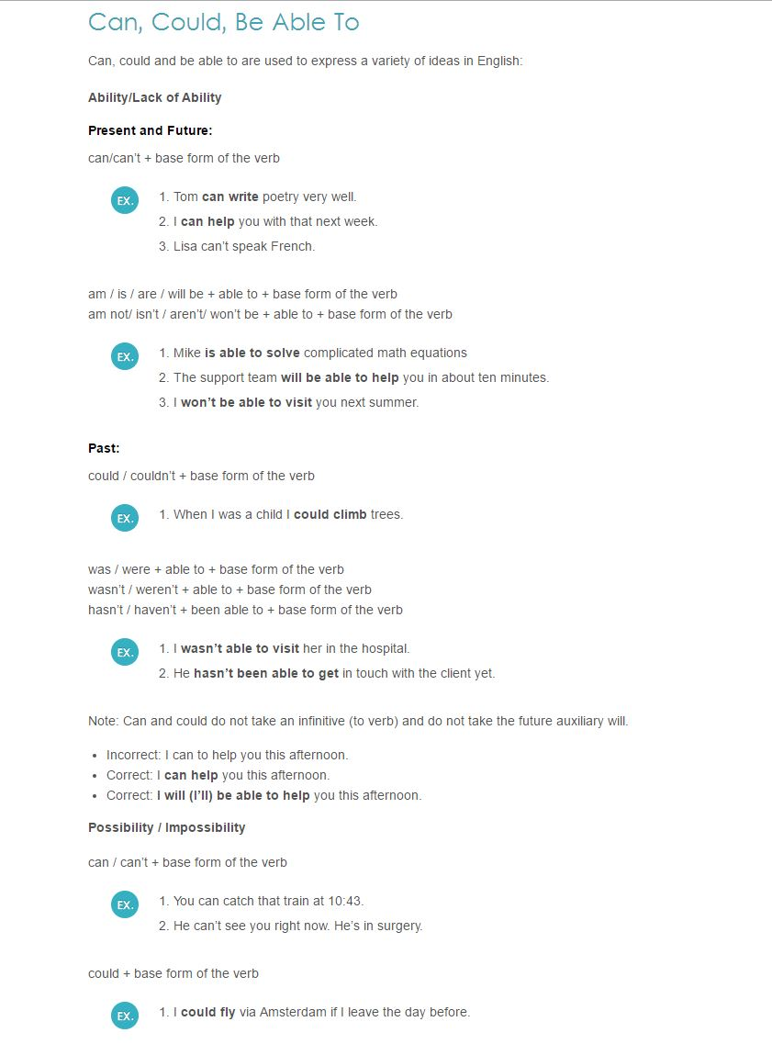  Lesson Plan: Hand Out page 1 (form 1) | 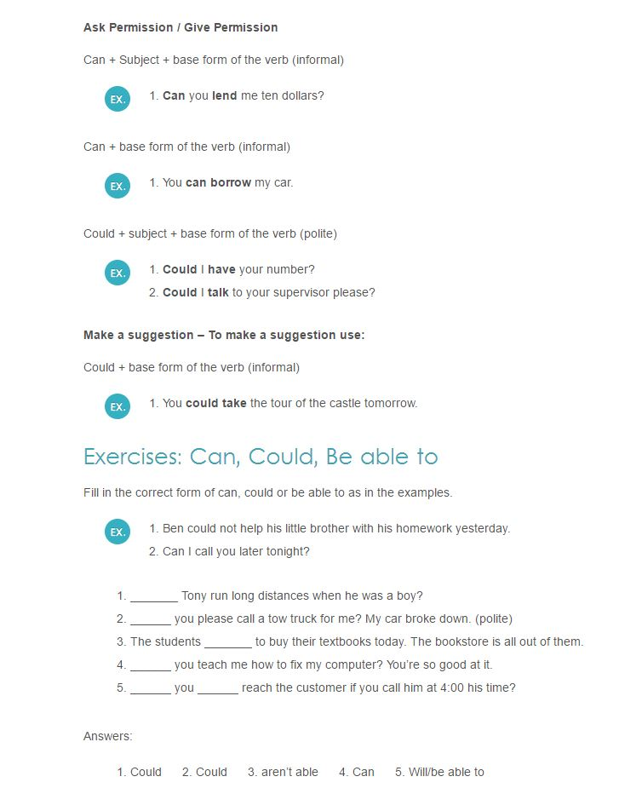  Lesson Plan: Hand Out page 2 (form 1)
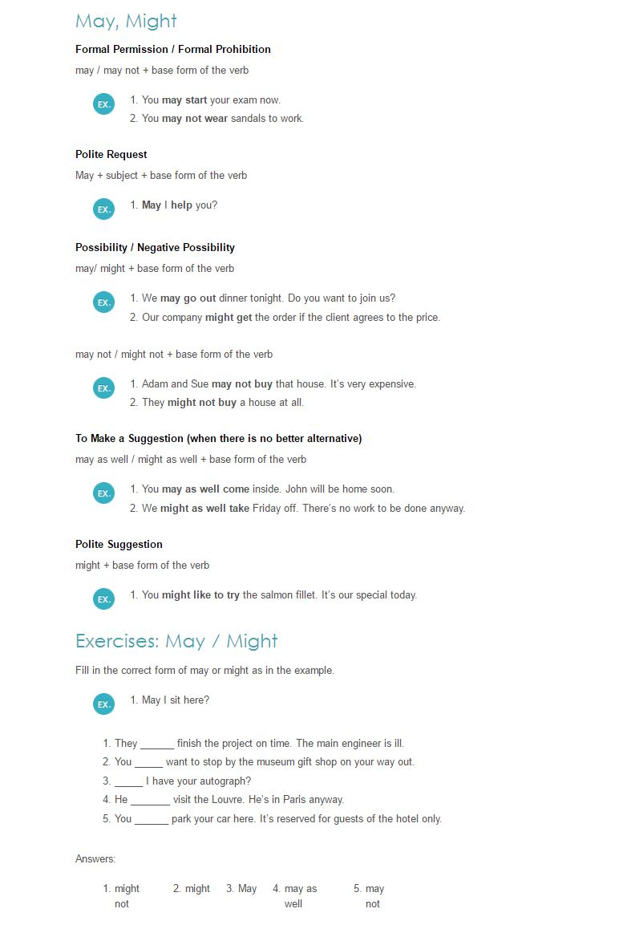  Lesson Plan: Hand Out page 3 (form 1) | 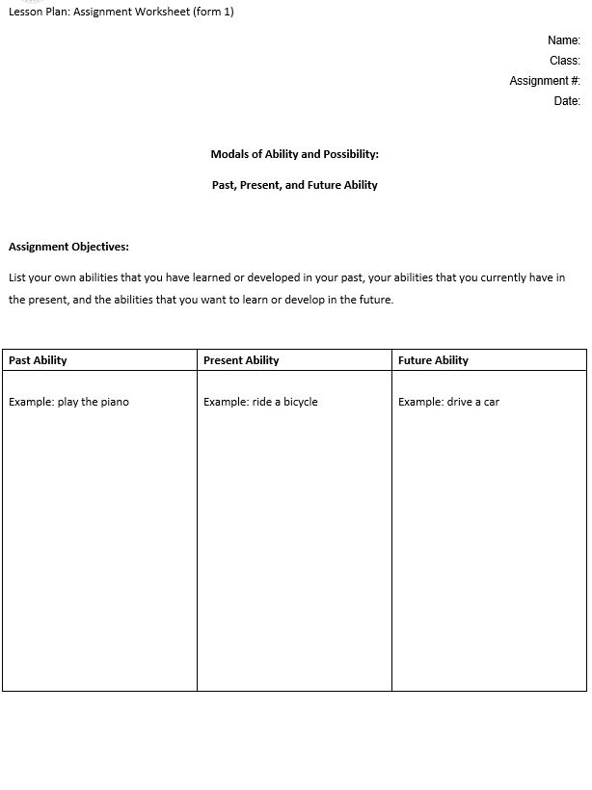  Lesson Plan: Assignment (form 2)

