MARIAH L. WOLFE
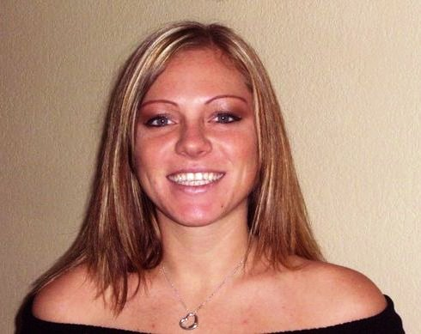
OBJECTIVE
Searching for a job to utilize all of my talents and work abilities. Obtaining a position that allows me to excel in my strengths. To use my fluent English skills and to share with others my knowledge instilled upon me. Exploring and understanding different cultures while using my strengths and abilities as a teacher.

PERSONAL

Nationality- American
DOB- August 10, 1983
Marital Status- Single
Preferred Location- None
Preferred Age- None
Religion- Christian
Apostilled Criminal Check- Last one 2010
Apostilled Dimploma- Yes
Preferred Area- Busan/Seoul or a larger small town.
Preferred Age- Kindergarden/Middle School
I just prefer good hours. Morning or night not required.
Available- About March/April 2014
Best Contact Time- Evening (Thai time)

PROFESSIONAL SKILLS

Strong organizational skills.
Self driven and highly motivated.
Computer literate- Microsoft word, Excel, Spreadsheet, Internet and E-mail.
Excellent at Multitasking.
Work extremely well with others.
Type 50 WPM

EDUCATION
Ridgewood High Port Richey, FL
High School Diploma 2001

Saint Leo University Saint Leo, FL
BA Degree (Criminology) 2006

TEFL Certificate Phuket, Thailand
120 hours 2010

EMPLOYMENT HISTORY

11/10- Current English Teacher Phuket, Thailand
Phuket International Kindergarten/School

5/10-9/10 English Teacher Phuket, Thailand
Phuket Witialaya High School

9/08-9/09 English Teacher Gimhae, South Korea
YBM ECC
Phone: 055-321-0509
Web: http://www.ybmecc.com/gimhae

10/07-9/08 Wolfe Chiropractic Centre Port Richey, FL
Office Manager

7/06-10/07 Tina Tapas Tampa, FL
Server

8/05-7/06 Dave Andreychuks Bar & Grill Tampa, FL
Server/Bartender

10/04-7/05 O’Briens Irish Pub Brandon, FL
Server

6/04-9/04 Johny Corinos Wesley Chapel, FL
Server

REFERENCES

Chris Vince
Course Director
chris@teflserver.net

Dr. Ed Dadez
Vice President of Saint Leo University
Ed.Dadez@saintleo.edu

Samantha Murchie
Highschool Teacher
smurchie@pasco.k12.fl.us

