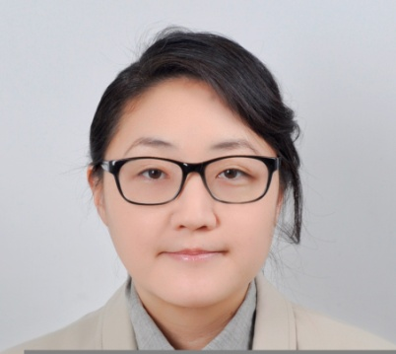

Linda Y. Lee

UCLA Graduate School of Education & Information Studies,
California Clear teaching credential, UCLA BA English with Honors,
four years education experience including EFL/ESL overseas

Education & Training

MA Theology June 2009 3.3 GPA
Fuller Theological Seminary, Pasadena CA

California Teaching Credential June 2002 4.0 GPA
UCLA Graduate School of Education & Information Studies , Los Angeles CA

BA English June 1997 3.6 Latin Honors
University of California Los Angeles, Los Angeles CA

Work Experience

English Kindergarten Teacher, Sep 2012- Feb 2013
Yesung Kindergarten, Gyeonggi, South Korea

- Integrating phonics instruction with kindergarten English program for ages 6 to 7
- Phonics Book, Reading Book, Chatter Book Story course curriculum and media
- After school classes in Storytelling and Intensive Reading for ages 5 through 7
- Developing emerging reading and language skills through conversation, reading, writing and storytelling

English Instructor, Jul 2012- Aug 2012
ICON Institute, Gyeonggi, South Korea

- Elementary, Middle school and High school level English as a Second Language instruction
- Curriculum application and development, in class discussion and homework instruction
- Reading and reading comprehension, grammar and writing and composition skills
- TOSEL mock test practice and language level testing

Kindergarten Teacher, Sep 2004- Jun 2005
Ravenswood City School District, East Palo Alto, CA

K-8 elementary and middle school serving urban community of EPA

- Provided comprehensive subject matter classroom instruction for kindergarten grade level in multiple subjects based on California state standards.
- Practiced research based ESL methods, language testing, language acquisition and phonology awareness instruction.
- Prepared students for advancement in reading, language arts, social studies and science through integrated subject lessons.

Computer Lab Teacher, Oct 2003-Jun 2004
Ravenswood City School District, East Palo Alto, CA

K-8 elementary and middle school serving urban community of EPA

- Provided computer lab instruction for elementary and middle school level grades 4-8.
- Implemented computer technology program applying software for reading and language arts curriculum.
- Assisted IT department in offering school wide technology support for laptop, desktop, printers, software and telecommunications.

Youth Director, Sep 2000- Dec 2001
Canaan Presbyterian Youth Group, Santa Ana, CA

Youth ministry for jr. high, high school and college students in Korean American community

- Served as youth director for middle, high school and college group in local Korean American youth ministry.
- Lead weekly worship services including messages and worship music program, supervised monthly bible studies and extra curricular activities.
- Assisted in curriculum and program development, coordinating with Lead and Associate Pastors to create quality educational program for youth.

English Instructor, Jun 2001-Jul 2001
OMF International, Dunhuang, China

Summer intensive English language program hosted by local ministry of education

- English as a second language instructor for 20 middle school students in summer intensive language immersion program.
- Lead instruction in grammar, writing, listening and speaking and coordinate extracurricular language activities.
- Provide English conversation session for native high school language instructors cooperating with ESL high school teachers.

English Instructor, Nov 1998-Jun 1999
Three Trees English School/ All Nations Language Institute, Seoul, Korea

International language institute for kindergarten through adult level students
- English language instructor and tutor for kindergarten through high school grade levels.
- Lead dynamic morning kindergarten program teaching music, phonics, spelling and conversation skills.
- Provide comprehensive instruction in listening, speaking, reading and writing, grammar, composition for all grade levels through high school.

Additional Experience

Writing Specialist, US Law Group, Glenview IL
Administrative Coordinator, YNOT Foundation, Los Angeles CA
Customer Service Administrator, Highel Inc., Irvine CA
Administrative Assistant, United Exchange Corp., Cerritos CA

Computer & Technical Skills

Operating Systems: Windows, Mac
Hardware: Scanners, Modems, CD-ROMs, Memory, Printers, Digital Cameras, LCD Projectors, Zip Drives
General Software: Office Suite, Adobe
Internet Software: Netscape Communicator (Navigator)
Presentation Software: PowerPoint

