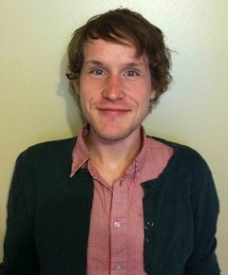

 | Joshua  Mattson | EDUCATION  University of Minnesota, Twin Cities  English, 2007-2011  Recipient of several creative writing scholarships. Had a play staged at the Rarig Center, a nationally known center for student theater. Ran and edited a literary magazine titled Gumshoe.  EXPERIENCE  Line Cook, Cupcake  Minneapolis, Minnesota 2010-Present  Responsible for prep, service, inventory, ordering, and customer service. Also responsible for training and mentoring new employees to uphold the high standards expected of an award-winning bakery. Cupcake is a busy full-service cafe popular among the students of the University of Minnesota and champion of the Food Network’s Cupcake Wars.  Intern, Piccolo  Minneapolis, Minnesota Fall 2012  Responsible for executing the pastry station at one of the finest restaurants in Minneapolis. Piccolo’s dedication to detail and adventurous use of ingredients has won them accolades from luminaries of the food world including Andrew Zimmern and Anthony Bourdain, who featured it on No Reservations.  ISD 181 Science Instructor  Brainerd, MN 2005-6  Designed an after-school science curriculum for K-5 students. Taught the curriculum three times a week for eight weeks per session. Developed mentorships with energetic children inclined towards chaos. Focused extensively on designing fun children’s activities that illustrated basic scientific principles.  REFERENCES  Available upon request.

