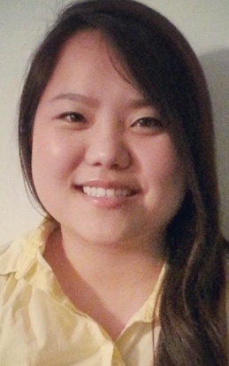
Jessica J. Park
EDUCATION FLORIDA STATE UNIVERSITY Tallahassee, Florida
Bachelor of Arts in English, April 2012
CERTIFICATES TEFL (TEACHING ENGLISH AS A FOREIGN LANGUAGE)
Expected to receive in December 2013
- 120-Hour Educator Certificate
- Grammar Advisor Endorsement
SKILLS Proficient in Adobe Premier Pro, Microsoft Word, PowerPoint, Excel, Vuvox
Ability to type 60-70 wpm
International Experience (South America, Central America, Europe, South Korea)
Experience with Spanish and Korean culture and language (Comprehensive in Spanish, Fluent in Conversational Korean)
EXPERIENCE
KEYSTONE KOREAN BAPTIST CHURCH
Translator
Odessa, Florida
August 2012- January 2013
Translation from Korean to English
NATURAL MARKET
Assistant Manager
Tampa, Florida
December 2012- July 2013
Experience in Human Resources
NATURAL MARKET
Employee
Tampa, Florida
April 2007- 2009
Gained customer service experience
Handled transactions
Inventory and Restocking experience
PIER 1 IMPORTS
Seasonal Employee
Tampa, Florida
October 2006-January2007
Gained customer service experience

ACTIVITIES
KUSA (Korean Undergraduate Student Association)
Member
Tallahassee, Florida
August 2007-April2008
ECHO (Emergency Care and Help Organization)
Volunteer
Tallahassee, Florida
January 2011-May2011

