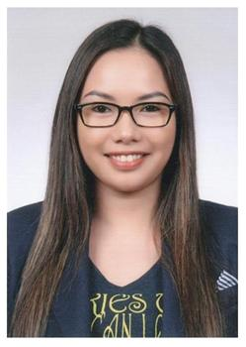
Jerollyn Gonzales #410-602, Halla Jugong 1-cha Apt., Ogeum-dong, Gunpo-si, Gyeonggi-do, South Korea 010-4074-9724 jerollyn10@yahoo.com
_____________________________________________________________________________________
PERSONAL INFORMATION:
Date of birth: 10 May 1983 Nationality: Filipino Marital status: Married Visa Type: F-2-1
JOB OBJECTIVE: Full-time English teacher
SUMMARY OF QUALIFICATIONS:
- Experienced English teacher to adults for over 6 years.
- Ability to effectively communicate with students from different diverse backgrounds or varying degrees of ability
- A committed and dedicated professional with a proven ability to teach, motivate and direct students to maximum performance by encouraging a positive and energetic environment.
- Ability to integrate theoretical concepts and practical ideas, and apply them to actual classroom situations.
- View teaching and learning as a dynamic and interactive process.
CAREER & CREDENTIAL:
- CELTA Certificate (January 2011)
(Certificate in English Language Teaching to Adults)
*Cambridge ESOL Level 5 Certificate in Teaching English to Speakers of other Languages

- English Teacher (2009 –2010)
Cultural Norte Americano (CNA)
Av. Goias, 679 Sao Caetano do Sul- Sao Paolo, Brazil
Tel.No: (11) 4227-4474

- English Teacher (2003-2008)
CNN International Language School (CNN)
4/f Claretian Communication building
#8 Mayumi St., UP Village, Diliman Quezon City, Philippines.
Tel.No: (63) 433-2432 Tel. fax: 433-2437
EDUCATIONAL BACKGROUND:
- Bachelor of Arts Major in Legal Management (2000-2003)
FEU-FERN College
Far Eastern University

RELEVANT TEACHING EXPERIENCE:
- As classroom teacher, built rapport with students from a wide range of cultural backgrounds.
- Developed resources and materials that was appropriate to students’ learning abilities and reflected their needs and interests.
- Created trusting atmosphere through sensitivity to students’ strengths, weaknesses, and personal learning styles.
- Engaged students through humor and activities designed for maximum interaction in large and small groups.
- Tailoring English teaching methods to suit the needs of individual students.

