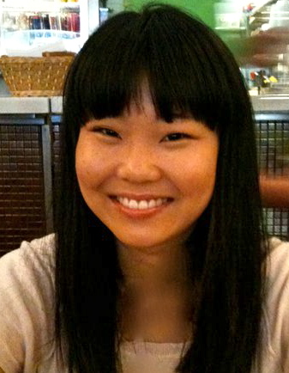
Jenna Creswick
Address: 125-10, Jahamun-ro, Jongno-gu, Seoul
Email: jenna.creswick@gmail.com
Cell phone: 010-3020-1734

Date of Birth: June, 12, 1987
Marital Status: Single
Nationality: Australian

Objective
- To gain full time employment in either a public or private school (institution) in Seoul, where my native English skills can be used to positively contribute to the learning and enhancement of Korean students with their English studies

Education

2006 – 2011

- Bachelor of Arts (Behavioural Studies), Monash University (Melbourne, AUSTRALIA)

- Bachelor of Business (Marketing), Monash University (Melbourne, AUSTRALIA)

2008

- Korean culture and language, KyungHee University (Seoul, SOUTH KOREA)

2008
- Professional TESOL certification - International English teacher’s license (AUSTRALASIAN TRAINING ACADEMY)
Majors: Teaching Pre-school
English for Elementary
Private Tuition

2001-2005

- Victorian Certificate of Education (VCE), Emmanuel College, (Warrnambool, Victoria, AUSTRALIA)

Skills and Qualities
- Highly organized and motivated
- Excellent communication skills
- Excellent ability to work in a team environment and/or individually
- Strong people skills including working with children
- Easily adaptable and open to new experiences and cultures

Experience: Work and Community

2013
Ewha Women’s University (Seoul SOUTH KOREA)
- Essential English Immersion Event
- Teaching Assistant

2010 – 2012
Department of Human Services (Melbourne, AUSTRALIA)
- Prepared and participated in panel talks and discussions

2010-2011
Monash University (Melbourne, AUSTRALIA)
- Assisted/tutored international students with university assignments including proofreading and editing

May 2008 – Aug 2008
Eastern Social Welfare Society, (Seoul SOUTH KOREA)

Duties:
- Assisted in the infant orphanage
- Edited English content
- Assisted with the rewriting of their English website
- Ensured website is effective and appropriate for clientele (native English speakers)

2007
International student friendship program, Monash University, (Clayton Campus AUSTRALIA)
- Befriended international students and assisted with their adjustment to university life in Australia

Travel Experience
- Lived and studied Korean language in Seoul, South Korea for eight months (2008)
- Travelled extensively throughout Australia, Europe including Scandinavia and the United Kingdom and South East Asia

Language Skills
- English (native)
- French (intermediate)
- Korean (basic)

Interests and Hobbies
- Travelling
- Languages
- Photography
- Art

References
- Available upon request

