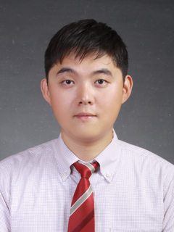

Han gon Yu 유한곤
Introduction |  | I am an American F4 holder, and I have been living and working primarily in Bundang since 2005. I have extensive knowledge and experience in the classroom, curriculum development, and management—the core areas of the ESL industry.
Skills & Abilities |  | - 8 years experience teaching English to Korean students, grades K through 7, specializing in vocabulary and grammar and writing instruction  - Able to produce quality classroom resources (worksheets, tests, student projects, etc.)  - Able to structure basic teaching curriculum and design basic courses  - Able to supervise foreign staff  - Fluent in conversational Korean
Experience |  | Academic coordinator, korea poly school – gwangmyeong campus  August ~ December 2005  Full-time instructor and academic coordinator  VICE DIRECTOR, KOREA CENTER FOR TALENTED YOUTH (KCTY) - BUNDANG  January 2006 ~ March 2013  Full-time instructor; Research & Development Manager (2008~2011); Vice Director (2012~2013)
Education |  | university of colorado at boulder – ba in anthropology  seattle university – certificate of tesol
PERSONAL STATEMENT |  | Over the years, I have built a solid foundation in Korea and have proved myself as a loyal, reliable employee to my previous employer, with whom I had spent a considerable part of my life here. Therefore, I am confident I will adapt to any professional environment with ease and minimal facilitation.
References |  | Bo Lee – Vice Director, KCTY (Bundang Campus) 010-8925-5941  koreacty@gmail.com | Keri Pynch – Vice Director, KCTY (Seocho Campus)  010-7771-1157

