Hongjoon Raphael Shin
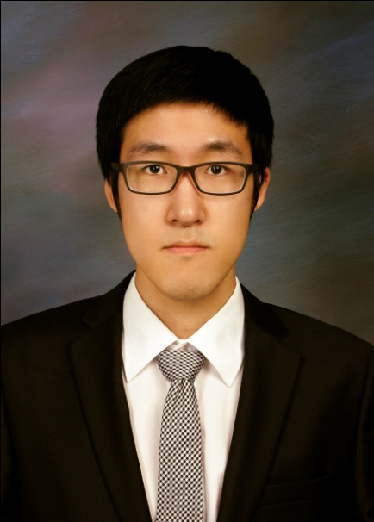

PERSONAL DETAILS

Address 서울시 강남구 대치동 889-56 더나인 오피스텔 1203호
Mobile Phone 010-2571-7544
Email hongijooni@hotmail.com

PERSONAL PROFILE

I possess a variety of attributes including teamwork, time management, leadership and great interpersonal skills to get along with numerous people of different diversities. My experiences as a head a treasurer in Korean student associations have contributed greatly in increasing these skills to become an effective team player.
With my education background from the University of Auckland in management and marketing which allowed me to have higher academic English skills and I am confident that I can transfer my English skills to teach students
I believed my skills and personality will offer you great and outcomes and make a significant impact for your academic school and to the student as well.

EDUCATION and TRAINING

The University of Auckland 2008-2010
Bachelor of Commerce (Majoring in Employment Relations & Human Resource Management and Promotional Marketing)

Orewa High School 2004-2007

WORK EXPERIENCE

Domino’s Pizza Red Beach - Sales 2007
Responsibility
- Preparation and serving pizzas. Had to meet the high expectations by the customers and required excellent customer service skills

Caregiver
Responsibility 2010-2011
- Had to look after special need kid with love and care over the summer

English Tutor
Responsibility
- Teaching English to students (3rd-6th graders) (listening, speaking, writing and reading)
Personal Skills and Qualities

Customer service and negotiation skills
- Through my experiences as a salesperson in domino, I have acquired customer skills that I ensure to deliver customer demands on time with kindness. In addition, I gained negotiation skills during the head treasurer time that I have negotiated terms and conditions with other departments of Korean student association and especially throughout the annual events I have negotiated prices and terms with contractors.

High Interpersonal Skills and Human Management Skills
- Extensive human management skills was required to motivate and manage junior treasure, also managed members to work together with other departments of student association also create highly organised and effective teams. I have know how to work with diversified people and to build ongoing relationship with team members to produce good quality of work.

Ability to Work Successfully as a Member of a Team
- Successfully worked in a team environment to achieve team goals. I have learned to work with people with different personalities in Korean student association and in Dominos pizzas. I have become better team player.

Time Management
- Constrained of time from managing work, personal commitments and the students associations at the same time
- Achieved effective time managements using diaries and online services to do everyday works
- Increased time management skills and ability to work under extreme time pressure
- Organised my work in order to reduce time wasting.

Strong Communication Skills
- An excellent communicator with excellent verbal and written communication skills in both English and Korean
- My role as the Head treasurer for the largest Korean Students Association involved working with the other departments of student association to finish the job
- Have acquired negotiation skills through with my role as the head to treasurer to solve the conflict and negotiate the terms that both parties want.

INTERESTS AND EXTRA CURRICULAR ACTIVITIES

Auckland Korean Students Association – Head Account
Responsibility
- Participated in various events organising processes to lead the association to success by preparing budgeting, grant and auditing.

Skills gained
- Very strong communication and interpersonal skills
- Ability to work as a team in variety of environments situations.
- Strong time management skills and strategies for effectively managing both personal and organisational responsibilities
- Negotiation skills in terms of closing the deal and resolving the problems with others.

Annual Korean Disabled Children Volunteer Helper in New Zealand 2010
- Every weekend visit Mil Al School (Korean disabled children school) to play with them and educate them with activities including origami, drawings and music.

REFEREES

Dong Jun Hur
UoA Korean Student association President(2010)
14E Baulcomb Parade, Albany, Auckland, New Zealand
021 181 2272
bunny_4_ever@hotmail.com

Sarubah Tiwary
Former owner of Domino’s Red Beach (2007)
021-294-0874

