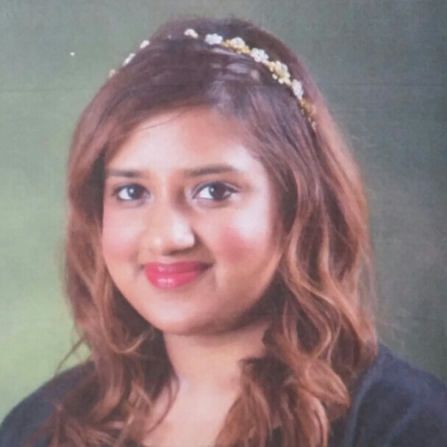
ZAANA HOOSEN

KID’S COLLEGE, Mapo-gu

Nationality: South African Birth date: 1986/11/05
Martial Status: Single

ACHIEVEMENTS AND SKILLS:

- Have four years experience in teaching English professionally in preschool and elementary environment
- Have excellent communication skill to deliver and present learning effectively
- Can create an enthusiastic environment and make learning a happy journey amongst children
- Creative and imaginative blend which helps in delivering lessons in a practical and interesting manner among children
- Have a caring attitude to attend to children’s needs and concerns in time.
- Have a strong desire to work with children

OBJECTIVE:

- To use my skills and experience and thereby to promote a positive atmosphere, and higher quality education amongst children.
- Seeking a challenging and responsible position to use my abilities and experience effectively and efficiently for children and I also have acquisition for learning and developing new skills.

EDUCATION

University of Kwa-Zulu Natal Jan. 2005 – April 2009/ Durban, South Africa

BA in social science

Major: Media and Sociology

EMPLOYMENT

LCI KIDS CLUB ACADEMY May. 2011 – March. 2012, Seoul

- Teaching English professionally in preschool and elementary environment
- Expertise with various teaching methodologies that would help children to learn English with interest and enthusiasm.

CEL CHILDREN EDUCATION FOR LIFE March. 2012- March 2013, Seoul

- Teaching kindergarten, middle school and elementary kids
- Teaching different age groups which requires different methodologies of teaching as per age group.

KID’S COLLEGE March. 2013- March 2015, Seoul

- Teaching kindergarten, middle school and elementary kids
- Teaching beginner and intermediate level English to different age groups kids that require different methodologies of teaching as per age group.
- Working as curriculum advisor for several English courses starting from March 2014 to present

COMPUTER AND LANGUAGE SKILLS
COMPUTER SKILLS

MS Windows 95, 98, XP; MS Office , 2000,2010/11 XP: MS Works MS

LANGUAGE SKILLS

English – | Native | Korean – Fair
References

- KID’S COLLEGE
Miss Jin (supervisor):
School: 027 168 686
Mobile: 010289 33913
Bitna (supervisor):
Mobile: 010 923 32497

- LCI
Adam (Head Teacher)
Mobile: 010 2409 1976

- CEL
Vicky (director)
Mobile: 010 658 74611

