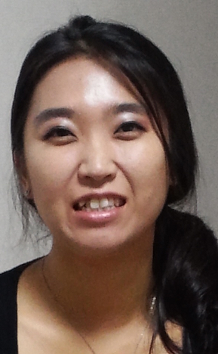

Eun Jung Kim
Date of Birth: 01/17/1984
Cell: 010-8689-2727
e-mail: Kim_ej@yahoo.com

Resume
Personal Statement:
I am currently a Full time English teacher in Hwasong. I am looking for a better job that will suit me. I have the dedication needed to be an excellent teacher. My goal is to teach young Koreans how to read, write, and communicate in the English language. I have done all my schooling in the United States from Kindergarten up to College.
Career Objective:
To obtain a teaching position at a school where I will have growth opportunity, work in a comfortable environment, and make money. I want to apply my skills where they will make a significant impact on the students that I teach. The ideal atmosphere would be at a school that is open to new ideas and tactics in developing the students English speaking/writing abilities.
Key Skills:
Problem Solving Fluent in English Teaching
Patience Fluent in Korean Hard-working
Customer Service Fast Learner Works well with kids

Work Experience:
February 2013- current
Holy Language School
Gyopo English Teacher

December 2012- February 2013
USEnglish
English Teacher

September 2012-December 2012
Water of Life
English Teacher

May 2011-May 2012
Calvery Chapel Green Valley
Children’s Ministry
Sunday School Teacher

June 2012-August 2012
Murietta Bible College
Bible College for Missions
Sunday School Teacher

August 2008-May 2011
Choice Hills Baptist Church
Children’s Ministry
Sunday School Teacher

Education
Nevada State College
January 2012- May2012
January 2013—May 2013
Major: Biology\ GPA :4.0

College of Southern Nevada
June-2010-May 2012
Major: Obtained Associate of Science\ GPA: 3.9
GPA: 3.9

Licenses, Certificates and Professional Organizations

Elementary Education Course in College
Certificate of Graduation at Barbizon Modeling School
Driver’s License, NV

Additional Skills and Information
Fluent in Korean and English
Computer literate
Type 45 wpm
Windows Vista and Seven
Customer Service
Call Center Experience
Excellent Communication Skills

