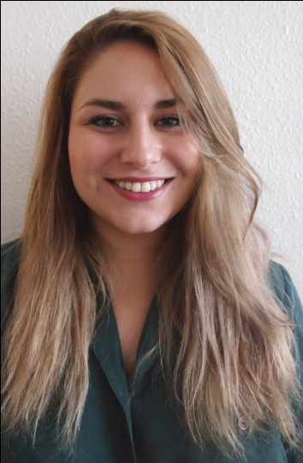

Nationality: British
Date of Birth: 31 May 1989

PROFILE
With an array of interests revolving around creating visuals via photography, illustration, painting, graphic design, fine art, animation, film making, designing, writing and languages, I am versatile and well rounded with a broad mind. Undertaking projects to constantly challenge my own way of thinking, I look to explore the new, fresh ideas which offer an exciting perspective. I am perpetually inspired by all things past, present and things that could be. I am currently looking to inspire via the universal platform of language.
EDUCATION
Global Language Training 2013: Online Master TEFL Course: Grade A
Modules include: Teaching Adults, Teaching young learners

University of the Creative Arts 2008 – 2011: Fashion Promotion and Imaging: BA (Hons)
London College of Fashion 2007 – 2008: Fashion Portfolio
Valentines Sixth Form 2005 – 2007
A Level’s: Art – A, Turkish – A, English – B, History – C
Valentines High School 2000 – 2005
GCSE’s: Art – A*, Media Studies – A, History – B, English Literature – A*, English Language – A, Turkish – A*, Double Science – B, Maths – C, Spanish – B, Double Business Studies – B

PREVIOUS WORK EXPERIENCE
Turkish – English Translator :2011 – 2013
I initially started Translation work as work experience with Mostafa Jallei Translation Agency (irexuk@gmail.com). I worked as a verbal translator for mainly Turkish speaking clients of solicitor firms, translating into Turkish for the client and into English for the solicitor. I have also worked in court where the work is fast paced in a controlled, professional environment. It is important to be confident and well spoken; eloquent with words. I also translate many written documents, including text books and essays. This work commands me to possess excellent speaking, writing, reading and listening skills in both the English and Turkish language. I am now continuing my Translation work Freelance.

Forever 21 : 09/2011 – 09/2012 Visual Merchandiser, Accessories Westfield Stratford City, Olympic Park
After graduating, I joined the newly established American retail store as part of their Accessories team. Due to my prior experience and evident hard work I was promoted to Visual Merchandiser of the department. As visual merchandiser my responsibilities include merchandising stock in a visually pleasing manner, keeping the floor fully stocked to optimise sales as well as delegating tasks and being responsible for and supervising those in my department. Through this I have developed good interpersonal skills and learnt to take on a leadership role.

Sarah Young : 04/2010 – 06/2010 Graphic Designer, Website, Stylist
www.iamsarahyoung.com - yo@iamsarahyoung.com
Interning for Sarah Young (Stylist, DJ, Writer) I assisted on Fashion shoots with Styling and Photography, as well as creating and editing editorials for the shoots. I created an accompanying graphic magazine for a Fashion Film she produced, also assisting on set. I worked on areas of promotion, updating graphics on her website, re-inventing and updating the look, designing a complete new website as well as designing flyers and creating promotional press packs. Working in a fast paced environment I became very hands on in all aspects and am creatively well rounded and innovative.

Gap Inc. Menswear :09/2007 – 10/2009 Sales Assistant, Personal Stylist 223 – 225 Oxford Street, London
I worked as a part of a large team in an extremely busy store where it was very fast paced, and important to work aptly. I worked as part of the sales team where my main job role was to interact with customers and help optimise sales while catering to their needs. It required me to develop a friendly and suitable personality. I was later promoted to ‘Personal Stylist’ due to my advanced creative outset and exceptional communication skills.

Salvation Army : 2005 – 2007 Voluntary Assistance Charity Shop, 15 Clements Road, Ilford
During my time at Salvation Army I was given additional responsibilities, these included displaying merchandise, arranging prices, till duties, handling new items as well as keeping the store in general order. Due to my responsible and efficient manner I was relied upon to take on a managerial position.

REFERENCES

Jo Holloway
Fashion Promotion Lecturer, UCA Epsom
jholloway1@ucreative.ac.uk

Jules Findley
Course Leader in Fashion Promotion and Imaging at University for the Creative Arts (UCA), Epsom
JFindley@ucreative.ac.uk

Dear Sir/Madam,
My name is Derya Sulun and I am a Fashion Promotion and Imaging graduate from London.
Currently, I am working as a freelance English-Turkish translator while I concentrate on my personal creative projects, consisting of a Science Fiction series which I hope to publish in the future. At this point in my life I am more interested in personal development and wish to utilise my skills in an educational environment.
My interest for languages stems from my own multicultural background; with Turkish as a secondary language, I willed to improve both languages through my work as a translator. Translating freely English into Turkish and vice versa, with all the necessary linguistic and grammatical rules in place, enabled me to develop a good command of both languages. To be capable of translation at a professional level, I am well versed in all four key skills necessary for fluency in any language; Writing, Reading, Speaking and Listening.
Through my constant practice of both languages, I have strengthened my belief in the importance of languages in communicating, not just between peoples, but also its use in helping transcend culture and pre-concieved notions. This has been the influencing factor into pursuing my talent for English in a more beneficial, educational environment. My most recent studies, undertaking a TEFL course, has confirmed my belief that teaching English is not just well suited, but also something I can be passionate about.
Combined with my appreciation for languages, my creative outset, and buoyant character, I feel I will be most suitable for this role which would require me to confidently engage with the students. Despite not having any prior teaching experience, I firmly believe I would make an excellent teacher, with my creative and professional background, I can not only command the class with well structured lessons, but also create a fun and enthusiastic environment for better learning. I believe captivating students through engaging activities is the most effective way of teaching a complex language like English, as motivation through the use of varying visual media will increase their desire to participate, creating good learning results.
I am confident my sincere teaching approach, as well as my education and work qualities make me a substantial candidate. I look forward to this opportunity,
Thank you for considering my application,
Yours faithfully,
Derya Sulun

