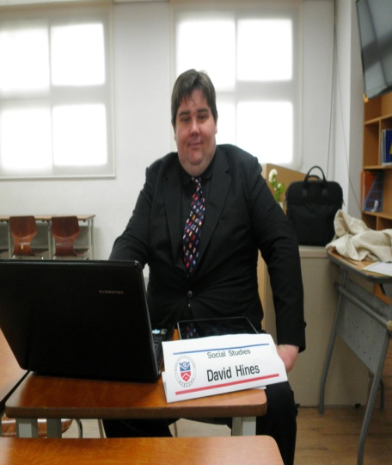

David Hines

CONTACT INFORMATION

405 South “R” Street
Lompoc, CA 93436, USA
davehines73@gmail.com
Skype: dave.hines73

OBJECTIVE

A position teaching English or Social Studies to Korean children K-12.

EDUCATION

Bachelor of Arts - Social Science, May 1999
Point Loma Nazarene University, San Diego, California

HONORS, AWARDS AND CERTIFICATIONS

100 Hour Teaching English in a Foreign Language certification (TEFL 100): 2012
Elected as Point Loma Nazarene University Associated Student Body Director of Activities: 1997-1998
Named to Who's Who Among Students In American Universities And Colleges: 1996-1997

RELATED WORK HISTORY

Lompoc Unified School District, Lompoc, CA (02/2012-present, 09/2008-02/2010, 12/2001-12/2003 and 01/2000-05/2000)
Substitute Teacher
Taught in elementary to high school classes in the absence of the regular teacher.

Global Vision Christian School, Eumseong & Mungyeong, South Korea (02/2010-07/2012)
U.S. History Teacher
Taught United States History and other subjects to Korean students in English.

San Diego City Schools, San Diego, CA (10/2000-12/2001)
Substitute Teacher
Taught in elementary to high school classes in the absence of the regular teacher.

SKILLS

Work very well with children
30+ years of computer experience and am often relied upon by co-workers for help with small computer issues

REFERENCES

References available upon request

