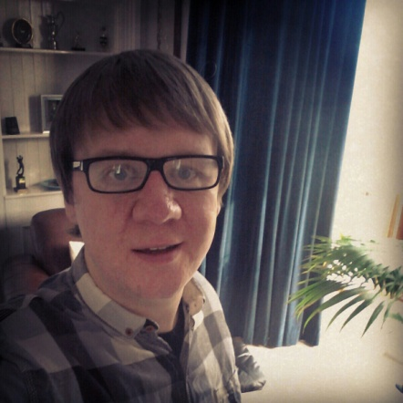
David Alexander brown

DOB 30/12/1977

10 Green Lane Carnoustie Angus Scotland DD7 6AA U.K.

Email: davidbrown77@hotmail.co.uk Phone: (+44) 01241 852873

Teaching Experience

Feb 2012 - Feb 2013 GnB English Academy, Seosan-si, Republic of Korea

Worked for 1 year at GnB Academy, Seosan, where I taught Elementary students all areas of English, including;

Writing
Vocabluary
Grammar
Speaking
Listening

June 2011 - August 2011 St. Thomas College, Gurutalawa, Sri Lanka

Teaching spoken/conversational English to 11-16 year olds
Assisting with written English exercises
Formulating lesson plans
Helping the children to improve their conversational English in every day settings
Assisting in the coaching of Soccer and Basketball
Teaching And Other Qualifications

August 2010 TEFL Scotland

Achieved certificate qualification in teaching English as a second language to non-native English Speakers (20 Hour TEFL Scotland Course).

September 2003 - May 2007 University of Dundee
Awarded Upper Second Class MA (Hons) in Politics from the University of Dundee.

September 2001 – May 2002 University of Dundee

Achieved a ‘Twilight Access’ award by way of Night Classes, allowing access to the University of Dundee’s Social/Life Sciences undergraduate program.

September 2008 – November 2009 University of Aberdeen

Post Graduate Diploma and Certificate in Muslims, Globalization and the West, Al-Maktoum Institute, Dundee (Awarding body is University of Aberdeen).

Personal Statement and Hobbies

I am a 35 year old, UK National, born and raised in Carnoustie, Scotland. I am degree educated, TEFL qualified and experienced teacher, hoping to further advance my career within the TEFL industry.

I believe that working in South Korea as an English teacher is a fantastic opportunity for me, both professionally and personally. Having lived in this wonderful country for almost 1 year now, I hope to forge a long term career here, hopefully I can do this whilst working for you.

Along with my experience here in Korea, I have also served as a volunteer English teacher at a rural, private school in Sri Lanka.

I am a very keen sportsman and regularly play soccer and golf, as well as snowboarding during the winter months. I was raised in Carnoustie and am a very keen golfer with a great love of the history and traditions of the game. I have also assisted friends and family members with no previous experience in learning how to play the game.

Being from Scotland I am blessed with some of the most beautiful and scenic countryside anywhere in the world, this allows me the chance to enjoy other outdoor pursuits such as canoeing, hill walking and camping, all of which I have been able to pursue while living in Korea. I also enjoy swimming, chess and reading.

International travel and experiencing foreign cultures is something I believe can make me not only a better teacher, but also a better person. My professional ambition is to forge a successful career as a TEFL teacher. I hope to gain as much experience as possible by working in an environment that challenges me and provides me with the tools to be the best TEFL teacher I can possibly be. With my combination of teaching experience, education, professional history, personal experiences and outgoing, friendly personality, I believe I am equipped to excel at your Academy.

References

Teaching;

Lee Su Nah
GnB English Academy
Won Joon Building (2F)
519-22 Seoklim-dong
Seosan-si
Chungnam
356-030
Republic of Korea

Email: hime611@gmail.com
Telephone: 01026000831

Professional;

Mr Richard Black,
Adecco UK Ltd.
21 Albert Square,
Town Centre,
Dundee,
Angus,
DD1 1DJ
Telephone - 01382 225 436
Richard is my former Supervising manager with Both Manpower Recruitment and with Adecco UK Ltd.

Academic;

Dr. Norrie MacQueen
n.j.d.macqueen@dundee.ac.uk
University of Dundee,
Politics Department,
Perth Road,
Dundee,
Angus,
DD1 4HN

Telephone - 01382 383 000
Dr. MacQueen was my tutor at the University of Dundee

