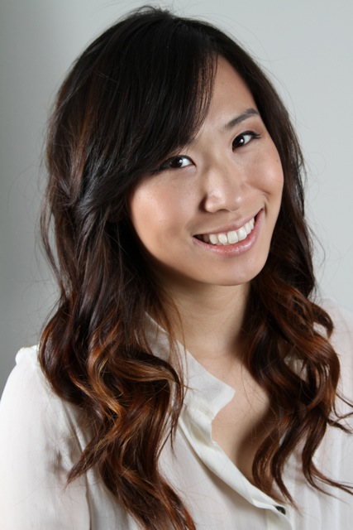

DANIELLE KIM

Objective |  | Ultimately earn the position of professor or Art Director
Experience |  | Maitre’d/Hostess Jan 2013  Management of all front of house operations, Fine Dining, Guest accommodations, book keeping VIP database, recording & reservation management  Private English Tutor 2007-2012  Established individual curriculums for undergraduate, graduate, and business/corporate conversation students. Tutored high school SAT reading, writing, and vocabulary.  Personal Assistant for Study Abroad Office (University of Texas at Arlington) Aug 2008- Jan 2009  Filing, promotional events, organizing databases/catalogs, mailing list
Education |  | University of Texas at Arlington May 2013  Bachelor of Art in Art – Minor in English/Creative Writing  Konkuk University – Study Abroad semester completion Aug 2011  Advanced English Literature, Advanced Film Analysis, Advanced Korean, Advanced Clay studio
Volunteer |  | Dallas Contemporary Art Museum  The Rachofsky House Art Gallery
 |  | References & Portfolio available upon request

