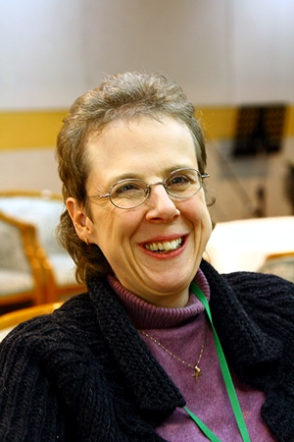
Curriculum Vitae
Alison Tomlinson

PERSONAL
Address: Room 102, 674 Ilwon-dong, Gangnam-gu, Seoul 135 230
서울시 강님구 일원동 674번지 102호 (135 230)
Telephone: Mobile (HP): 010 9163 0663
Email: alison.tomlinson@gmail.com
Nationality: British
Date of birth: 19 February 1959

TRAINING
1981 BSc (hons) Music from The City University, London, England.
1998 RSA/UCLES CELTA (Certificate in English Language Teaching to Adults)
from Leeds Metropolitan University, Leeds, England.

WORK HISTORY AND EXPERIENCE
(Between 1987 to 1998 I held various positions as an administrator in England.)

July-Aug 1998 Teaching English to adults at Functional English in Whitby, England.
1998 - 1999 Teaching English to adults at Southall School of Languages, London, England
1999 - 2000 Teaching English to children at Sisa (시사) Foreign Language Institute, Gyeongju, S. Korea.
2000 - 2005 Teaching English to children at Global Language School Gyeongju, S. Korea.
2005 - 2006 Teaching English to adults at ETC (English Training Center) Gyeongju, S. Korea.

(2006-2007 studied Korean at Busan National University)

2008 - 2009 Teaching English to kindergarten children at TNT School, Seoul.
March 2009 – present Teaching English to university students at the Korean Bible University, Seoul
(한국성서대학교)
REFERENCES
Current Employer: 김영국 (영어학 박사)
Korean Bible University (한국성서대학교)
16 Danghyeon 2(I)-gil, Nowon-gu, Seoul 139 791
Telephone: 02 950 5525
Mobile: 011 9059 1147
Email: kimykook@bible.ac.kr

Previous Employer: 신동석 (실장님),
TNT School, 마포구 대흥동 500-10, 창희 BD 2/3F
Telephone: 02 706 7946
Mobile: 010 6276 8884
Email: chief@tntschool.com

Previous Employer: 임진홍 (원장님)
ETC Language Institute
#780-180 620-448 Sunggun Dong, Gyeongju
Telephone: 054 773 6521
Mobile: 011 9853 6252
Email: etclim@hotmail.com

Personal: Rev. Esther Berg
Minister at AIM, Sooyoungno Church in Busan.
Mobile: 010 6773 5796
Email: rev.esther@gmail.com

