Education:
I have double majors. 1. B.S. from Southern Illinois University, Carbondale Illinois within the College of Human Resources in Child and Family, specializing in Early Childhood Development and Education. Awards: Dean’s list second quarter of freshman year and last semester before graduation Top fifth of graduating class. I received the S.I.U. Trustees Award for Honorable Service in ROTC. 2. ROTC was my second major. I was Commissioned as an Air Force Lt. from Southern Illinois University Air Force ROTC and Separated from the service in May of 1986
Experience: Kindergarten/Elementary ESL teacher for 21st Century Language Institute July 2007~December, 2012 in Suwon, South Korea. Kindergarten/Elementary ESL teacher for Mokdong GKI English Language Institute June2006~July 2007 Mokdong, South Korea Vault/NSF Clerk 2000-2006 Costco Wholesale, Inc., Chicago, Illinois Managed and allocated the vault funds and deposits for an individual warehouse. Made collections and filed police reports on NSF/Fraud cases. Provided Administration/payroll/sales audit assistance when needed. Provided back-up LP when needed. English Native Speaker Teacher 1995-2000 South Korea. English teacher for the South Korean Army Intelligence School. English teacher for several private institutes in Suwon and Seoul, South Korea. English teacher for Samsung Electronics Global Management Center. English teacher for Hyundai Aerospace Development Division. English teacher for Samsung Electronics Customer Service Director-Private Class. Marketing Manager 1990-1995 Photo Express, San Diego, California, Analysis of current/future marketing for client procurement Development of sales and advertisement. Consultation for the procurement of equipment in the photo lab. Handled the Direct Sales to Client. Professional Pre-School Teacher/Home Day Care Owner 1982-1995 Early Childhood education instruction and care. Full Charge Bookkeeper 1980-1982 El Torito Restaurants, Inc. La Jolla, California. Maintained the Accounts Receivable/Accounts Payable/ General Ledger. Maintained the books and postings for an individual restaurant with Payroll/Insurance for 75-150 employees Audited billings, charges for the restaurant.

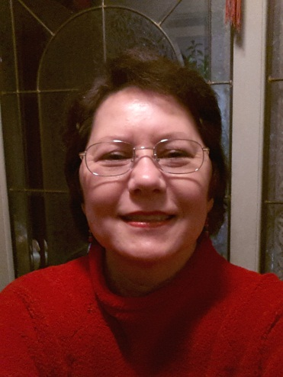
Hello!
My name is Kimberly Sharp-Ko. I am currently looking for a teaching position…part-time or full-time. I only require a salary, a small housing allowance and possibly a gas allowance. I take care of everything else.
I am a native speaker of English and a US citizen, but hold an F-4 Visa. All of my education has been in US and International schools in English. I speak very little Korean. My specialty is Preschool/Kindergarten. I have a B.S. in Child and Family from Southern Illinois University-Carbondale. My total teaching time equals 17 years. I taught for three years in preschools in the USA, owned and ran a licensed, home-preschool for three years and have taught ESL in Korea for eleven years. I can design and write lesson plans, teach phonics and reading, and give general instruction in writing and grammar. I am a non-certified teacher in the States, which means that I can teach at private schools, but not public in the States. Overseas, I can teach almost anywhere. I can provide a structured, motherly atmosphere for the students.
I am also a retired US Air Force Lt. and COSTCO employee, so I am quite used to working in a team environment. If you are interested in an interview, the best way to contact me is by E-Mail at maxmandyhkco@hotmail.com. I look forward to hearing from you in the near future.
Sincerely,
Kimberly

