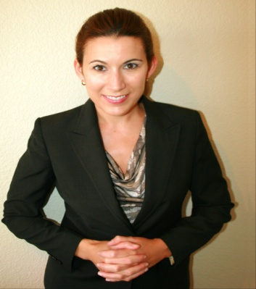

Crystal Williams
7135 Navajo Rd #1313
San Diego, CA 92119

Cmwill619@gmail.com

OBJECTIVE :

To obtain a teaching position in an elementary school.

PROFILE :

A highly enthusiastic and creative individual with vast multicultural experience. Dedicated to providing the best education and care to children and adult learners of all ages.

EXPERIENCE :

Hope House, Norfolk, Virginia, USA, 2006-2008

Job Coach

Assisted developmentally disabled adults in living independently. Trained individuals on employment skills, speaking, and interacting with the community.

Soldier’s Family Association, British Army, Dusseldorf, Germany, 2005-2006

Victim Support Manager

Served as a trainer for a charity on a one-year contract. Prepared Criminal Justice assignments for adult military students, reviewed and corrected all homework with an emphasis on providing feedback to each student.

United States Air Force, Hampton, Virginia, USA, 1998-2003

Created training program for military police. Delivered classes and staged practical examinations, resulting in a 100% pass rate on standardized testing.

Columbia College, Columbia, MO, 2007-2011

Bachelor of Arts in History

