Christine Y.S. Lim
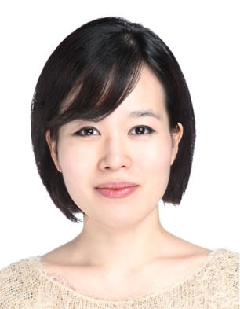

Personal Details
Date of Birth: 1987, April 15
Citizenship: Canadian
Mother Tongue: English
Marital Status: Single
Health: Healthy
Visa Status: F-4
Expected Starting Date: Sept.2, 2013 (will arrive at Incheon Airport on Aug. 22, 2013)

Objective
To obtain a full-time position as an English instructor which will allow me to use my communication, interpretation, and empathetic listening skills to encourage learning and motivate children and adults to speak, write and listen with confidence and ease.

Education
2011 – 2013 Kwantlen Polytechnic University Surrey,BC BA degree in Human Resources Management Completed on July 20, 2013
Coursework includes: Training &Coaching, Communication,
Human Relations, Business Leadership, Negotiation, Organizational
Development

2008 Oxford Seminars Vancouver, BC
TESOL/TESL certification
Specialization in Business English & TOEFL

2007 – 2008 Langara College Vancouver, BC
University Transfer Program – Commerce (2nd year finished)

2006 University of British Columbia Kelowna, BC
Pre-pharmacy Program (one-year complete)

2001 – 2006 Burnaby South Secondary School Burnaby, BC
High School Diploma
1998 – 2001 Betty Gilbert Elementary School Langley, BC

Employment Experience
2013 Inno Bakery Ltd. Vancouver, BC
(May-July) Human Resources Consultant
- Established a recruitment & selection plan to help the organization prepare for the launch of the new store opening in September, 2013.

2013 King George International College Vancouver, BC
(Jan-April) Human Resources Consultant
- Created a performance assessment program to help the skill development & career growth of the administrative assistants in the organization.

2013-07-31 Vancouver & Lower Mainland Multicultural Family
(Jan-April) Support Service Society Burnaby, BC
Human Resources Consultant
- Revised the organization’s OHS manual and established a training program to update & test the employee’s OHS knowledge.

2009 - 2010 Topia Language Institute S. Korea
(Oct.-Nov.) Foreign Head Instructor/English Instructor
- Taught TOEFL Speaking, Writing, Debate, and Listening, World Studies, and Reading (Elem – Junior High)
- Interpreted/translated over 50 meetings held in Korean to English
- Directed & Managed meetings for native (non-local) teachers
- Monitored/evaluated students’ performance, attitudes, and behaviors
- Offered counseling to students and parents
- Developed lesson plans/activities

2009 Gyeong-ju English Village Summer Camp S. Korea
(April-May) Instructor
- Taught intermediate conversation, writing & listening through various indoor/outdoor activities at the 5-week camp, held by the Korea Herald Edu Co. and the city.
- Developed lesson plans/learning exercises
- Directed a group (20-25) of students to follow procedures/regulations

2009 E-Commerce Burnaby, BC
Marketing Director
- Planned & scheduled weekly meetings, delivered presentations on e-commerce & economic issues, and did product demos

2007 Privately Employed Vancouver, BC
English Tutor
- Taught adults (international students) pronunciation, conversation, writing & listening through various activities

2006 Privately Employed Vancouver, BC
Social Studies Tutor
- Taught Gr.11 curriculum using textbooks and self-made materials

2005 SFU Summer Camp Burnaby, BC
Assistant Instructor
- Planned & prepared program materials, instruct & direct students to follow a provided curriculum

Relevant Skills and Experience
Languages: Fluent in English & Korean (i.e. bilingual)

Relevant Skills: Cross-cultural competency, social intelligence, and
Transdisciplinarity

Travel Experience: USA (California, New York, LA, Seattle, etc.); Australia (Sydney); New Zealand; Korea

Awards
2005-2006 Business Information Management, Gr. 12
2004 The Award for Perseverance & Industry in Social Studies 10
2000-2001 Class Act for Outstanding Achievement in Academic, Sport, and/or Community Involvement
2001 Certificate for Academic Achievement
2001 Certificate of Appreciation for Volunteering

References
Christine Yeseul Lim

PRESENT ADDRESS
#48-6089 Willingdon Avenue
Buranby, B.C., V5H2T9
(604)358-0415

Mr. Daniel Yoon
Topia Bukgwangju Campus/President
Yong-Bong Center B/D 3,4,5F., 1385-6 Yong-Bong Dong,
500-846, Gwang-Ju, Korea
Tel: +82-62-605-2000
Fax: +82-62-529-1390
Email: danieljyy@naver.com
Mr. Yoon was President of Topia Bukgwanju Campus, the language institute where I used to work for over a year.
Mr. Choongyeop Yeo
Herald Media Inc./Director
Daegu-si Namgu Dae-myong 2dong 1796-6 2nd floor,
S. Korea
Tel: +82-10-3536-7893
Email: evernov@naver.com
Mr. Yeo was the director when I worked as an instructor at Gyeong-ju English Villege.
Dr. Le Roi Smith
Entrepreneurial Dept./Professor
Kwantlen Polytechnic University
8771 Lansdowne Road, Richmond
British Columbia, Canada
Email: diversity@shaw.ca
faculty@shaw.ca
Dr. Smith was my professor for Leadership (4th year) in university.

Letter of Reference

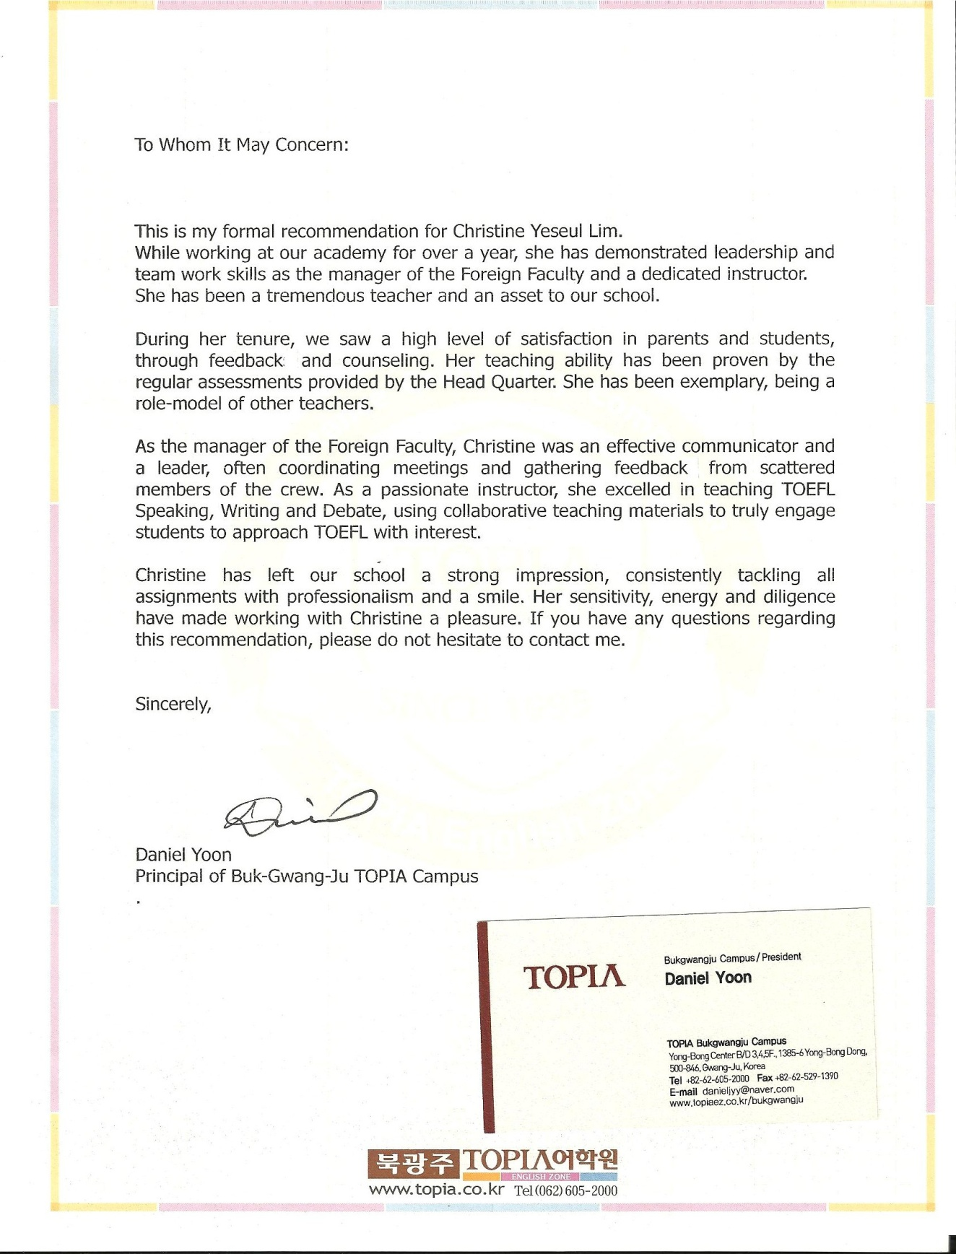

TESOL/TESL Practicum Evaluation
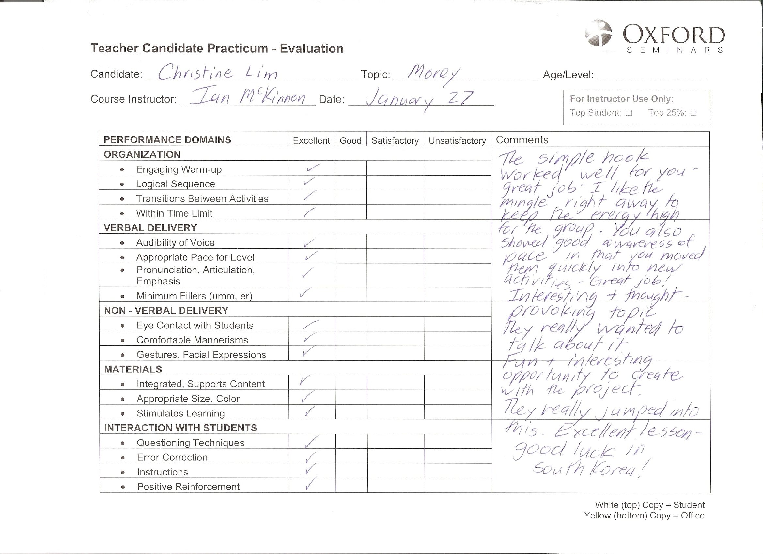

TESOL/TESL Certifications
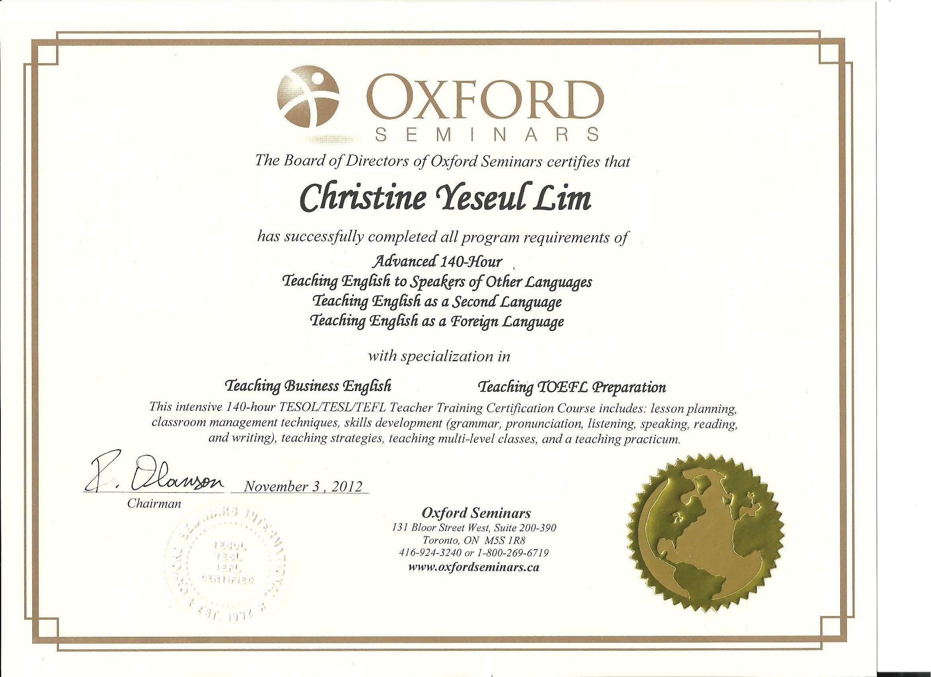
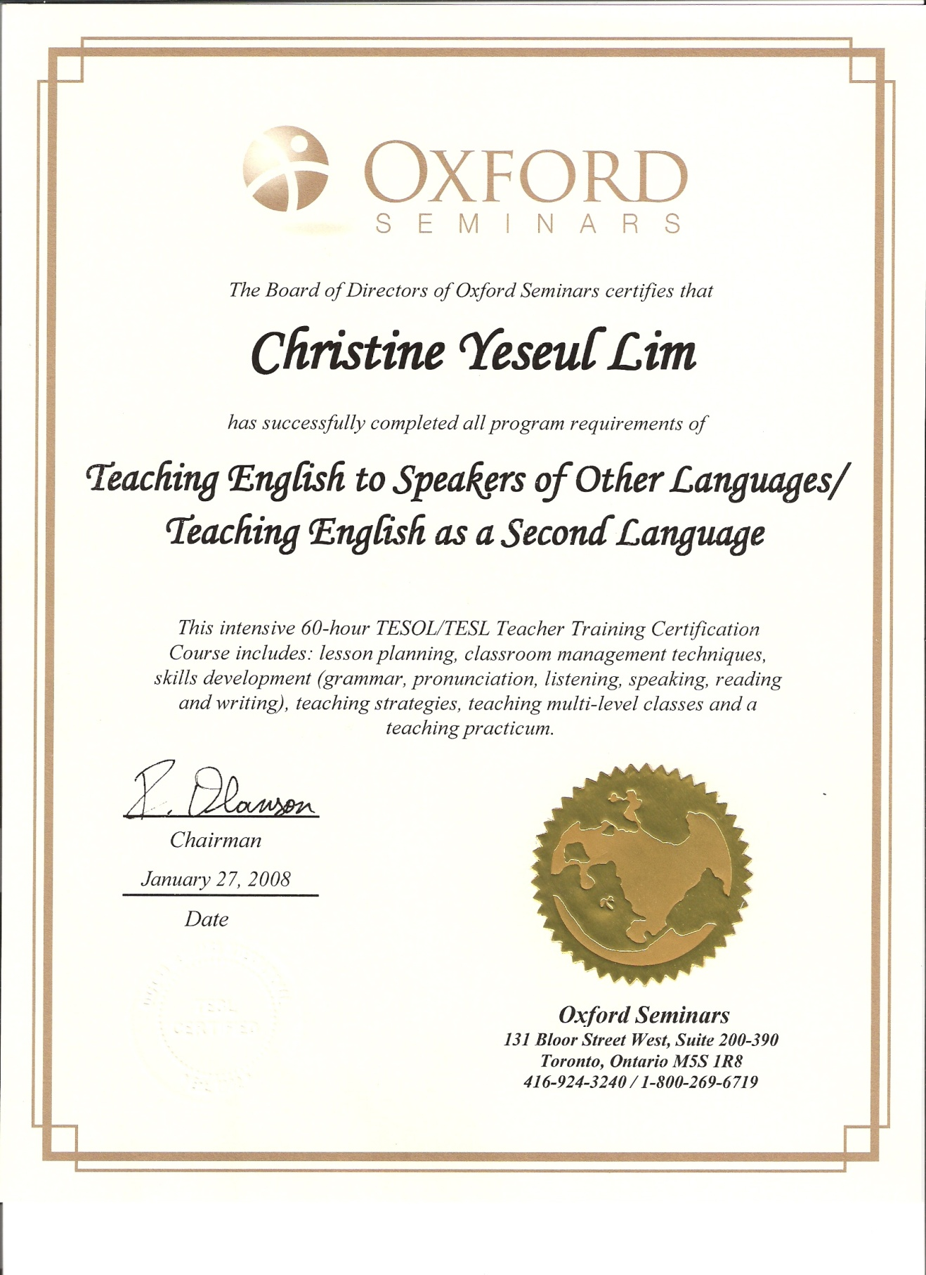

Cover letter & Resume

31 July 2013

Dear Sirs/Madam

As a certified and an experienced professional, I believe my knowledge, skills and ability are a good fit for a full-time teaching position at your school. Completing the TESOL/TESL certification - in January 2008 - from Oxford Seminars has helped me develop teaching strategies and classroom management skills. Moreover, over two years of work experience as a tutor and an English instructor has allowed me to become proficient in teaching students of all ages (Elementary–Adults). Furthermore, through the recent TESOL/TESL certification upgrade, I gained a better understanding of test preparation and teaching strategies. I also gained a theoretical and practical overview of how to teach Business English in the classroom.

The studies which I have done in Human Resources Management are deeply associated to my teaching career. As I worked towards this business degree, I have developed strong analytical, research, critical thinking and communication skills. My diverse educational/employment background has prepared me with the skills and flexibility to teach English overseas. I easily adapt to new a new environment and am open to challenges and opportunities. I pride myself on my optimistic outlook, self-motivation and attention to details. These characteristic will enable me to succeed in teaching ESL in your school.

I believe an effective teacher must provide and maintain a positive and supportive learning environment to facilitate second language learning and individual student growth. As a teacher, I will aim to create a supportive yet dynamic environment that addresses the learning styles of all students and encourage them to participate. I am committed to helping students reach their full potential.

Attached you will find my resume which outlines my education, skills and experience. I am very interested in scheduling an interview at a time that is convenient for you. As a TESOL/TESL trained teacher who is self-motivated, flexible and organized, I hope you'll consider me for a position with your organization. I appreciate your consideration of my application and thank you for your time.

Respectfully,

X Christine Lim

