TO WHOM IT MAY CONCERN:

I am an enthusiastic 25 year old male with a BTech in marketing. I enjoy spending time with children, especially when it comes to their unique ways of thinking and doing, because that is what sets them apart from the rest of us. To be able to help them grow mentally in their own unique ways is something that I find indescribable. Even if it is just to teach them English, it will be something that will be part of them for the rest of their lives and may just one day be a key factor in their lives that can help change their lives forever. As each and every child is unique in their own way and to be able to help a child express himself/herself in another language is outstanding, be it in any of the three forms of communication (speak, read and write) is truly remarkable.

I am also a hardworking individual who enjoys challenges and will take anything “head on”. I believe that children should be well mannered, yet be able to express themselves to a degree. My somewhat different ways of teaching will help any child to learn English without them actually realising it. There are various techniques available depending on the age. The key is to find what they love be it animals, technology, clothes or even gossip about celebrities.

I grew up in a town that consisted majority of English speaking residents as well as coming from a bilingual household. My mother comes from an English household and my father from an Afrikaans household. Although I went to an Afrikaans school, majority of my friends growing up were English speaking. Therefore growing up, speaking English was a daily routine. I also completed my studies in BTECH Marketing in English, which manage to increase my English knowledge even further.

TO WHOM IT MAY CONCERN
CURRICULUM VITAE
LE CLUE LEACH

CURRICULUM VITAE

- PERSONAL DETAILS
Surname : Leach
First name : Le Clue
Place and date of birth : East London 29-01-1985
Nationality : South Africa
Identity number : 8501295096084
Driver’s license : Code B
Transport : Own vehicle
Current employment : Technician/Supervisor (360 Degrees Security)
Address : 4 Alocasia St
Zonnendal Estate
Kraaifontein
7570
Cellular phone : 084 506 7839
Email address : lecluesemail@gmail.com
Home language : Afrikaans
Other languages : English (speak, read and write fluently)

ACADEMIC DETAILS
Matriculation
School : Grens High School
Year : 2003
Certificate : Cape Senior Certificate
Subject, grades and symbols : Afrikaans 1st language HG - C
English 2nd language HG - B
Biology HG - E
Geography HG - D
Maths SG - D
Tourism SG - D

Higher Education
University : Nelson Mandela Metropolitan University
Year : 2004 – 2007
Diploma : National Diploma: Marketing (Completed in English)
BTech : BTech Marketing (Completed in English)
Subjects completed : Accounting for Marketers 1
Advertising & Sales Promotion 1
Communication in English A
Consumer Behaviour 1
Computers: End User 1
Economics 1
Law for Marketers 1: Law of Contract &
Specific Contracts & Capita Selecta
Marketing 1
Personal selling 1
Quantitative Techniques 1 Module A & B
Marketing 2
Marketing 3: International Marketing
Small Business
Marketing Research 3
Sales Management 3
Advance Finance 4
Marketing 4: Strategic Marketing

University : University of South Africa
Year : 2008
Subject completed : Applied promotions 4
Marketing research 4

EMPLOYMENT EXPERIENCE DUTIES
Blue Lagoon Hotel : Barman
(March 2003 – December 2003)
(November 2004 – January 2005)
(November 2005 – January 2006)
: Serving customers
Stock bar
Clean bar
Prep bar

Kaffrarian Assurance Brokers : Administration clerk
(June 2006)
: Data capturing

Lucia`s Vending : Manager
(2002-2007)
: Banking
Bicycle repairs
Cash up
Stock controlling
Book vendors in and out

Kilowatt AV : Marketing Internship
(February 2008 – April 2008)

Beverage Merchandising
Promotions (BMP) : Senior Merchandiser
: (May 2008 – March 2009)
: Stock rotation
Promotion implementation
Display building
Check and report expiration
Taking photos
Collect and submit findings
Assisted manager with time to time

360 Degrees Security : Technician/Supervisor
(April 2009 till present)
: Install and maintain CCTV
Install and maintain electrified fencing
Collect stock and supplies
Organise invoices accordingly
Site supervisor

COMPUTER LITERACY
I am able to use the following computer programmes competently:
Internet Explorer MS Excel
MS Word MS Office Outlook
MS PowerPoint

REFEREES
The following employers have agreed to act as my referees:
Mr Johan P Leach Mrs M Lucia Leach
Owner: Kaffrarian Assurance Brokers Owner: Lucia`s Vending
Telephone: 082 577 3162 Telephone: 084 472 9625

Mr Dillon Jeary Mr Shahiem Erasmus
Owner: Kilowatt AV Key Account Manager: SABMILLER
Telephone: 082 745 8800 Telephone: 082 921 7567

Mr Stephen Du Preez Darius Leach
Regional Manager: BMP Owner: 360 Degrees Security
Telephone: 082 322 8317 Telephone: 072 212 3933
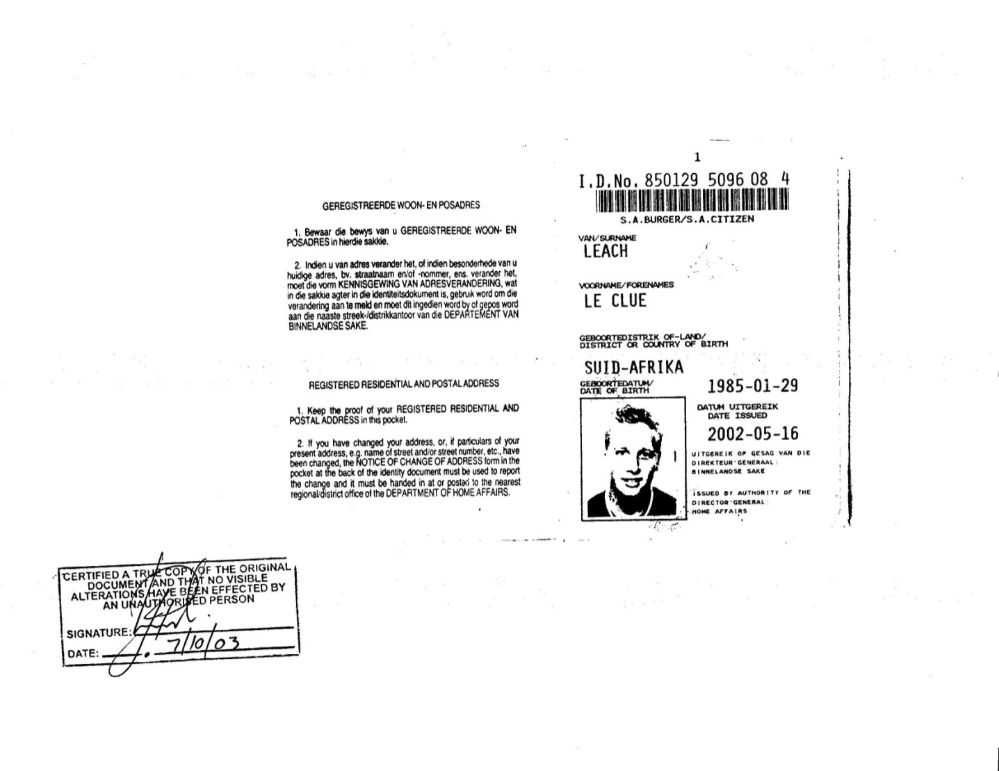
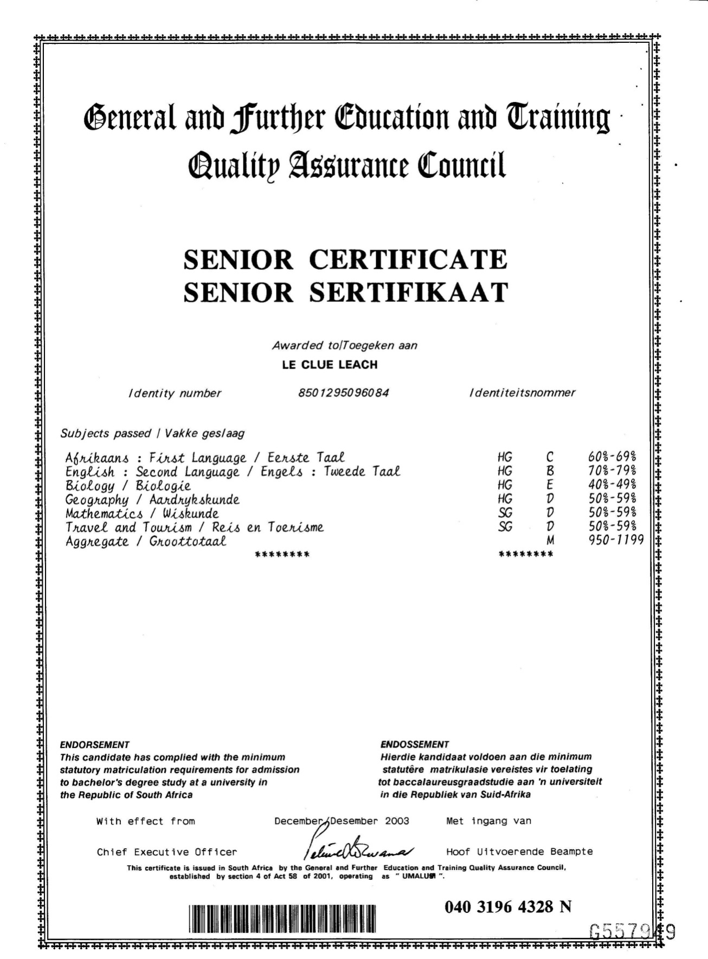
Proof of degree will be available from April 2010

