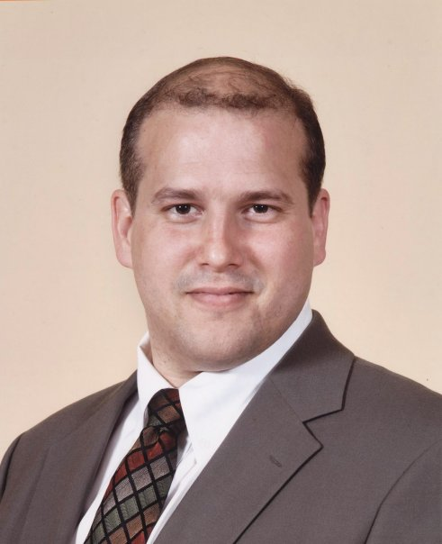Qualifications
American Citizen and Graduate. Currently Employed.
Four consecutive ESL contracts completed in Korea.
Satisfied Employers. Married, one child. Travelled.
DOB. 10/11/1968
Charles M. K. Bingham
39-4 Changui-ri, Seorak-myeon
Gapyeong-gun, Gyeonggi-do
South Korea 477-852
cbingham@bridgeport.edu
010-63-85-3082

Education
International TEFL Teacher Training South Korea
TEFL Certification, 120 hours, grade: A 2011
International TEFL Corporation South Korea
TEYL Certification, 50 hours 2011
University of Bridgeport Bridgeport, CT, USA
International College, Religion, BA Suma Cum Laude (3.9 GPA) 2005-2007
Phi Kappa Phi Recipient (most selective American academic honor)
Editor-in-Chief, Student Paper
Hampshire College Amherst, MA, USA
American University in Paris Paris, France

Teaching Experience
Miwon Public Elementary School Seorak-myeon, Gapyeong
ESL Instructor, GEPIK 2010-present
Cheongshim Church Academy Gapyeong
ESL Instructor, 4th-9th Grades 2007-2010
University of Bridgeport, English Language Institute Bridgeport, CT, USA
ESL Instructor, Level Placement Tester, Undergraduate 2007
U B, Academic Resource Center Bridgeport, CT, USA
Part-time Writing Tutor for ESL Students 2006

