Brett Chauvin

216 Dubois Ave, Emeryville, On., N0R 1C0

(519)-727-6849

chauvinb@uwindsor.ca

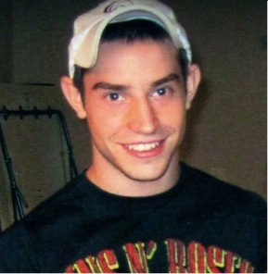
Eh Losa,

Well I have my background check and certificate of diploma with the notarized Korean Consulate Seal.
Yes, please introduce me to any position in Seoul.
My skype ID is taken14theteam. You can contact me until 2pm today :) thanks so much!

Sincerely,
Brett

Education | High School Degree  St. Anne’e High School, Tecumseh, On.  Ontario Scholar Level | 09/2001-06/2005
 | B.A. Economics Major  University of Windsor, Windsor, On.  Minor in Business Administration | 09/2008-04/2011

Employment
 | English Instructor YBM ECC  - Responsible for classroom/behavioral management with children of young ages.  - Enhancement and development of English skills taught as a second language. | 9/2011-8/2012
 | Tutor  - Responsible for teaching, encouraging and enhancing skills in a particular subject.  - Creating an environment that is directing yet captures attention. | 3/2009-12/2009
 | Referee, Belle River Minor Soccer  - Dealing with conflict resolution via parents and coaches.  - Responsible for safety as well as leadership of the children on the field. | 04/2003-08/2005

Volunteer Experience
- 40 hours community service in high school
- Lay reader for St. William’s Church
- Raised $900 with a team of individuals for LDAWE, a Charity in Windsor Essex County.
- Canvassed for the Heart & Stroke Foundation in order to raise money and awareness for heart disease.

