Branden Bueno Smith 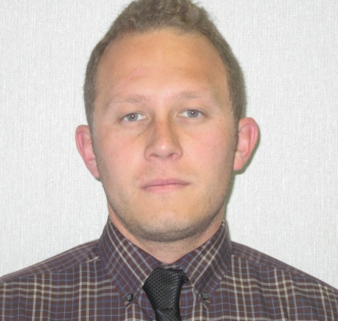
126 E. Campus View Dr.
Riverside, CA 92507
+86 1-352-835-4433
Email: bueno.smith@gmail.com / octopusshark@hotmail.com

Professional Profile
Enthusiastic about teaching the English language to international students in a communicative and student-centered atmosphere.
- Experience in teaching English language acquisition in reading, speaking, and writing instruction.
- Dedicated to providing quality instruction through preparation and with a commitment to learning.

Education & Certifications
TEFL Certified University of California Riverside 2011
Teaching practicum: 160 in class hrs. focused around a student-centered, communicative environment emphasizing current second language teaching theories, methodology and pedagogy. A variety of innovative strategies were used teaching English learners from Japanese, Swedish and Arabic speaking countries.

B.A. Social Sciences, Sociology & Institution Development
San Diego State University, San Diego CA, 2010
Recipient of the Thomas Riviera Scholarship

Teaching Experience

Jiangmen No. 1 Middle School
Jiangmen, Guangdong Province, People’s Republic of China
2013-2014
Teacher and Head Coordinator of English Curriculum for Grades 1, 2 & 3. Grade 3 curriculum is largely based and developed around preparation for the Chinese High School Exit Exam, College entrance exams and readiness for taking the ITELS exam.

Zi Cha
2014- Present
Instructor of primary students in communicative English. Jiangmen, Guangdong, PRC.

American Indian Recruitment Higher Education Program
San Diego, CA. UCSD, USD, SDSU Participation
2009-2010
Taught Middle School and High School level students in a unique and progressive educational program, advising them to the advantages of higher education and in several cases helping them through the university application process. Worked one on one with students and mentored in formal class setting.

Environment California
2005-2006
Worked with Environment California, lobbing to State Legislators and the public to pass AB 32, California Global Warming Solutions Act of 2006.
Taught classes and held seminars for both the organization and to the public consulting them on the California energy crisis, relevant legislation and solutions.

Informal Educational Positions

Reid Park / Parks & Recreation Physical Education Department Riverside, CA
1997-2003
-Basketball Head Coach/ Programs Leader / Coordinator
-Soccer Head Coach Children’s Program

Personal Tutor to the Wolfe Family
2008-2011 Reading comprehension & Writing proficiency for Elementary age students.

Personal Tutor to the Li Family
2014-Present Personal tutor in advanced conversational English

Callaway Vineyard and Winery Temecula, CA
2010-2013
Taught seminars on agricultural sustainability in regards to wine production in both the grape growing and wine making process.
Docent and liaison for Callaway Winery.

Work History & Personal and Professional References available upon request

Applicable Skills Familiar with Computer Assisted Language Learning as well as CPR and First Aid certified

