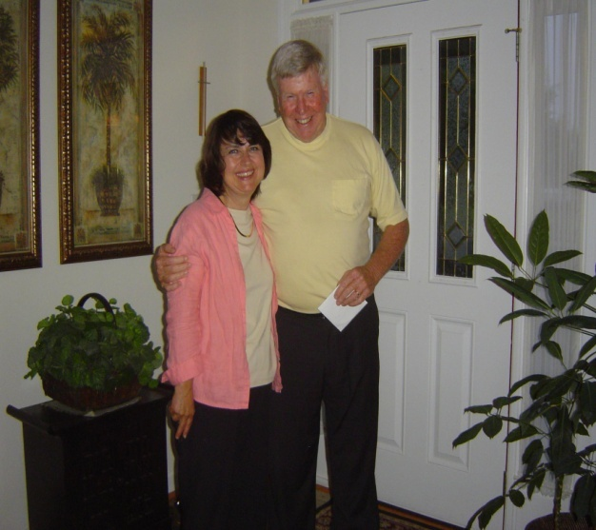

Bill Bosworth

KOREA Tel. – 010 4464 4311 Email: bbosworth7@gmail.com

OBJECTIVE:

ESL/EFL TEACHER

QUALIFICATIONS

- Experienced communicator in teaching English in South Korea for the past 2 plus years to Kindergartner, Elementary, Mid High, High School, College and Adults
- Coordinator of English as a Second Language Program for over 200 Internationals in USA
- Trained under and mentored by the ESL Trainer for the SIM International ESL Certificate Program in Charlotte, N.C., USA
- Skilled in development and implementation of long and short range lesson planning in ESL
- Designed and implemented lesson plans for teaching all levels of Conversational English
- Have taught from the following curriculums: American Headway; English Land; Phonics Star; Face to Face; Vocabulary Connections; Boost!; Shining Star; Exploring English; Backpack; NorthStar; Side by Side; Building Skills for the TOEFL IBT
- Computer Skills in Word, Excel and Power Point
- Experienced in working with teams

WORK HISTORY

ESL Professor Kangwon National University, Samcheok, South Korea Present Teaching to be completed by December of 2009

ESL Teacher GCS GROUP in Chuncheon, South Korea Dec. 2007 to Dec. 2008

ESL Teacher International English School, South Korea June 2007 to Dec. 2007

ESL Coordinator/Director Program in Charlotte, N.C. USA Sept 2006 to June 2007

Coordinator
- Taught U.S. Citizenship classes
- Taught ESL Classes

Executive Director B and B Bell Company Leadership Training Teacher

Director/Teacher Brosend Camp, Conference and Retreat Center
- Represented the camp, conference and retreat center in the community, in the public schools, and in government agencies.

EDUCATION

Columbia International University CIU's Distance Learning course: Foundation for Curriculum Present
B.A. Scarritt College Behavioral Science Major: Missions Minor: Bible
M.A. Scarritt College Education (includes supervision, management, teaching, etc.)

References

GCS Group, Korea General Manager-Eric Tel. 02 2202 6684 Cell 010 5153 0150
ESL Program Charlotte N.C. USA Manager Dr. Lynn Haines Tel. USA 704 843 6700

