Junghoon Bernard Lee
Jan. 02, 1987
Seoul Kwanak Bongchun 1603-5 203
Cell (010) 9326-2377
hunymuny@hotmail.com
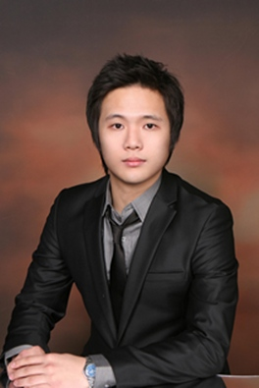
Personal Profile

- Recognized for being a team player, and excellent quality of work.
- Great leadership skills, excellent planning and organization skills, quick learner, responsible and honest.
- Fluent in English and Korean.
- Skilled on using Microsoft word.
- Resident of Canada over 8years.
- Although I may be young, I am well qualified for any job given onto me with precise details and great management

Education

- York Mills C.I – High School Diploma
Graduated in 2005
- University of Guelph – majoring in Hotel Management
Graduating in June of 2010

Work Experience

Private tutor 2007 Jan - 2007 June
- Taught various subjects for undergrads, such as English and Marketing.
- Help them with examinations and students’ individual assignments.
- Demonstrated excellent problem solving skills when dealing with students.

Manager at a bar 2005 Jan - 2007 Jan
- Responsible for motivating employees.
- Managed bar operations and administration including scheduling, reports, inventory and customer service.
- Other responsibilities include: supervising staff of over 8 employees and responsible for team development communication, sales, profit and cost control management.

Academy school 2009 Oct – Feb
Taught at Eastern English academy school for 4-5 months in korea

Volunteer Work

Concert for Fundraising 2004 July – 2007 Aug
- Performed as a vocal of the band.
- Delegated assignments to team members during the event preparation process.

Personal Interests

- Played in a soccer team as a mid fielder from 2002-2003(won 1st place in Toronto Korean Soccer)
- Performed Te-kwon-do on multicultural day in high school.

