Benjamin Gibbons
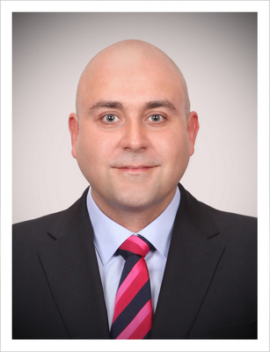403ho, 10-4Songpa-dong, Songpa-Gu, Seoul Korea 138-848
Visa status: F-6-1. Nationality: English

D.O.B: 1981/01/07

Profile
CELTA certified teacher dedicated and passionate about teaching. Committed to utilising effective,modern techniques to enhance student retention and enjoyment of English.

Key Skills and Attributes
- Over five years teaching experience.
- Over two years of management experience.
- Sensitive to the needs of Korean students.
- Builds good rapport with students and co-workers.
- Excellent communication skills.

Education
2007: Intensive School of English, Brighton, England
- CELTA - Certificate of English Language Teaching to Adults
- 120 hours; certified by Cambridge University

2004 – 2007:University of Sussex, Brighton, England
- Bachelors of Arts (with Honours) in Geography

Work Experience
2012 – Present – Korea Agency of Education, Promotion and Information Service in Food, Agriculture, Forestry and Fisheries (EPIS)Anyang, Gyeonggi-do
Teaching business English, to the International Trade and Co-Operation Team. Focus on negotiation skills, presentations, cross cultural business practices, meetings skills and current event discussion to a group of advanced level students.

2012 – Present –3030 English.Maseok, Gyeonggi-do
Teaching a mix of both elementary and adult students at a small private academy. Elementary students are of beginner to intermediate level and learn speaking and listening. Adults are of an intermediate to advanced level and are taught TOEIC and OPIc test preparation.

2010 – Present – Co-Founder – EnglishinKorean.com
Co-founded an English teaching website and podcast offering free English language classes to Korean learners. The podcast now has over 50,000 regular listeners and over 5000 subscribers to its YouTube channel.

2007 – 2012 – Native English Teacher Team Leader – Choisun DYB.Daechi-dong, Seoul
Managed teams of teachers, in both elementary and middle school branches of the largest English language academy in Daechi-dong, Seoul. Taught TOEFL speaking and writing, academic essay composition, debate and general classes from beginner to advanced level. Other duties included report writing, curriculum development, general administration duties, and teacher training.

2010 – 2010 – Business English Teacher – Samsung Construction.Seocho-gu, Seoul
Taught Senior Vice Presidents on a 1-1 basis. Classes ranged from general conversation to negotiation, meetings, listening, e-mail and telephone etiquette, presentation skills and preparation for the OPIc test.

2006 - 2007 – Private English Tutor, Brighton, England
Tutoring a Korean woman for approximately 2 hours per day, 5 days a week. Focussing on conversational English, reading and listening.

2005 - 2007 - Elite Incident Management – Incident Response Agent
2004 - 2004 - Knightscross Security Ltd – Door Supervisor
2003 - 2004 - Client Logic – Customer Service Agent
2000 - 2002 - Fiat and Alfa Romeo – Fiat Fleet Executive

Hobbies and Interests
In my spare time I enjoy hiking, cookery, soccer, film and socialising.

References
References available upon request.

