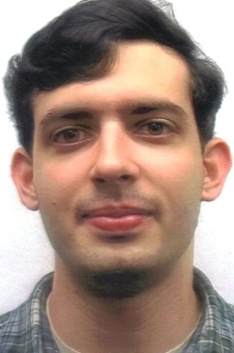
AMOS FAROOQI
EDUCATION
Fordham University, New York, NY
Bachelor of Arts in International Studies; Concentration on Asia, Expected May 2013
Major GPA 3.47; Cumulative GPA: 3.1

Yonsei University, Seoul, South Korea, February 2012- June 2012

TEACHING & RELATED EXPERIENCE
Seoulmates Language Exchange Program, Volunteer, Seoul, South Korea, March- July 2012
- Taught idioms, vocabulary, grammar, and American culture to a group of 4 Korean College students.
- Improved English conversational skills of the college students, as well as enhanced own Korean language speaking ability.
- Honed communication and interpersonal skills by explaining certain aspects of the English language.

BACK Project, Volunteer, Seoul, South Korea, March- May 2012
- Participated in community service program through study abroad program, CIEE.
- Worked with North Korean refugees in high school on improving their English conversational skills.
- Instructed refugees on grammar, spelling, and vocabulary.

Plymouth Church Vacation Bible Camp, Arts and Crafts Counselor, Brooklyn, NY, July 2009
- Created arts and crafts projects for children, aged 3-8, to complete before class.
- Assisted and guided the children with their projects by providing suggestions and advice.
- Curated the arts and crafts pieces which were presented to the parents on the last day of camp.

ADDITIONAL EXPERIENCE
Plymouth Church Underground Thrift Store, Security Guard, Brooklyn, NY, Nov. 2011-Feb.2012; Oct. 2012-Present
- Maintain church and ensure safety from potential intruders.
- Display exceptional customer service skills and assist the elderly in entering the store.

Plymouth Church, Fireguard, Brooklyn, NY, June-November 2011
- Licensed by the Fire Department of New York to safeguard the church while its fire alarm systems were under renovation.
- Conducted walkthrough of the Church every hour to ensure fire extinguishers were charged, exits were clear, and there were no fire hazards.

RCN, Marketing Intern, Long Island City, NY, June-August 2010
- Created and arranged marketing displays and assisted in advertising RCN at a number of local events.
- Promoted advertising material to potential customers through papering neighborhoods.
- Expanded the database of potential customers by a few hundred through event sign-ups.
- Strengthened ability to work in a team-oriented environment and complete tasks in an efficient manner.

Offices of Fmr. New York City Councilman, David Yassky, Intern, Brooklyn, NY, June- August 2008
- Filed reports on potential city infrastructure projects, such as the Newtown Creek Sewage Treatment Plant and the Croton Water Filtration Plant project, on their costs and benefits.
- Assisted the public relations officer for the councilman with setting up appointments and events with the councilman’s constituency.

LANGUAGE & COMPUTER SKILLS
Basic conversational Korean; Proficient with Microsoft Word and PowerPoint.

