Allen Moghanloo

206-88 RedPath Ave, Toronto, ON, M4S 2J8, Canada
Ph: 010-3040-6601
E-mail: sincer2007@yahoo.ca

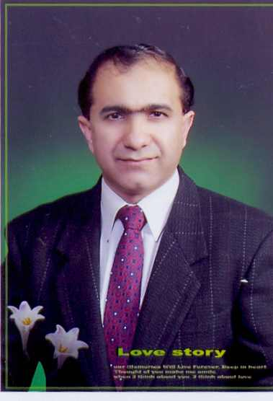

Professional Profile

Eager to bring kindergarten and elementary students into the twenty-first century using a unique combination of education experience coupled with ten years’ business background in computer systems management.

Hold Bachelor Degree From Trinity International University

TESOL Teaching Certificate

Key Qualifications

Certified in Kindergarten and Elementary and Business Education

Plan and instruct each subject area using wide variety of teaching aids, motivational and implementation strategies to engage students in active learning.

Incorporate learning modality principles into classroom and individual instruction. Develop and conduct inter-grade activities. Utilize Heath automated math management system.

Implement technological approaches to subject material. Research educational resources on the Internet. Assist with information retrieval.

Employment

Professional Development in Education

Pagoda Private School January 2008 to July 2008 in Ssangmun, Taught conversation and reading practice and writing to the elementary students from level 3~5.

GNB Private Academy in Seoul Mokdong, taught conversation to elementary students from grade 1~5 from 2007 to 2008.

Boston Academy in Deajeon, Winter 2006 ~ 2007.
Taught young children using a variety of instructional methods including cooperative learning and use of learning centers. Planned several learning centers as well as instructional games/aids. Planned and supervised a field trip. Created and wrote newsletter for parents to keep them updated on class events and the progress of their child.

TUTOR / INSTUCTOR Pert Logan Elementary School, Canada. 2005 ~ 2006
Tutored elementary school students in all subject areas. Specialized in increasing reading & writing ability.

Professional Affiliations
International Reading Association
Association for Supervision and Curriculum Development

SCHOOL RELATED INTERESTS

Interested in participating in team teaching, grade level curriculum writing, and drug abuse resistance programming. Plan to utilize multicultural approaches and resources in the classroom.

Others

Traveled to most Asian and European countries & able to communicate in other languages as well.

