Agnes B. Rodrigo 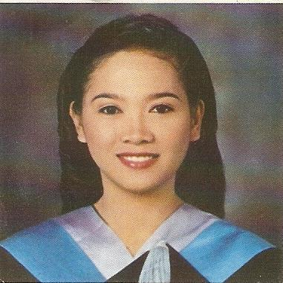
Gyeonggi-du Goyang City Deokyanggu
Hwajeong-dung 965
Hanwa Obelisk Rm.2408, South Korea
Mobile No.: (82)10-5115-7719
Email Add: agnessee_rodrigo@yahoo.com
Philippine address:
85-H Katipunan St. Cebu City, 6000 Philippines
EDUCATIONAL BACKGROUND
POST GRADUATE: Year [From] – [To]
Course: Master Units in Special Education 2008 – 2009
School: Cebu State College of Science and Technology
Address: M.J. Cuenco Ave. Cebu City, Philippines

Course: Diploma in Special Education 2007 – 2008
School: Cebu State College of Science and Technology
Address: M.J. Cuenco Ave. Cebu City, Philippines

University:
Course: Bachelor in Elementary Education ( graduate ) 2000 – 2004
School: Cebu Normal University
Address: Osmena Blvd. Cebu City, Phlippines

Secondary:
School: Cebu City Don Carlos A. Gothong High School 1996 – 2000
Address: C. Padilla St. Cebu City, Philppines

Elementary:
School: San Nicolas Elementary School 1990 – 1996
Address: Carlock St. Cebu City, Philippines

EMPLOYMENT HISTORY

Position: ESL Instructor
Academy: Sam-Sung Multi English Academy
Address: Talamban, Cebu City, Philippines
Date: October 2006 – February 2009

Job Description/Duties and Responsibilities:
. 1:1 ( individualized instruction)
Teaches general conversational English.
. Creates avenue for the student to practice speaking and writing together with reading and listening.
. Prepares lessons carefully designed to meet the needs of the student.
1:4 ( small group)
Prepares lesson for a small group providing scenarios where students can interact and use the language in the given situation.
. Lessons are designed to fit in a small group interaction.

Position: ESL Instructor
Academy: Philippine Cebu Agus International School
Address: Brgy. Agus Lapu Lapu City, Philippines
Date: May 2005- September 2006

Job Description/Duties and Responsibilities:

1:1 ( individualized instruction)
Teaches general conversational English.
. Creates avenue for the student to practice speaking and writing together with reading and listening.
. Prepares lessons carefully designed to meet the needs of the student.
1:4 ( small group)
Prepares lesson for a small group providing scenarios where students can interact and use the language in the given situation.
. Lessons are designed to fit in a small group interaction.

SPECIAL SKILLS/INTERESTS
. Can read and write Korean language.
. Can speak a little Korean. Completed the level 1 course of Korean Language Program in International Language Institute of Hongik University and currently taking the level 2 program at the same University.
. Well-versed in oral and written English
. Reading novel
. Listening to music
. Watching movies

