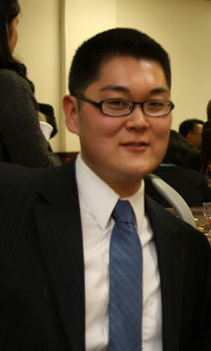

JOSEPH CHUNG

1142 #202 Singok-ri, Gochon-eup, Gimpo-si, Gyeonggi-do 415-819
010-3836-3294 ◙ Jsphchung@gmail.com

Nationality: American Visa: F4 Hometown: New York, NY Age: 25 (1988)

I am a highly motivated and energetic English teacher with three years of proven classroom experience under my belt. I've taught from a small school on an island of 300 students, to a much larger school in the city with well over 1,100 students. I've also taught advanced classes at the county level and conducted training for fellow teachers.

EDUCATION

Bachelor’s Degree in Political Science at Baruch College, The City University of New York
100-Hour TESOL Certificate, International Teacher’s TEFL Training

TEACHING EXPERIENCE

Gochon Middle School, Gimpo, South Korea
English Teacher, April 2013 – March 2014
Taught middle school students; Developed and designed weekly lesson plans, PowerPoint, and other teaching materials; Taught after school classes; Supervised winter and summer camp programs; Judged English pop song singing contests, Created exam questions; Prepped students for high school interviews,

Deokhyeon Middle School, Yangju, South Korea
English Teacher, April 2012 – March 2013
Taught middle school students; Developed and designed weekly lesson plans, PowerPoint, and other teaching materials; Designed and supervised winter and summer camp programs; Served as a judge for English-speaking contests; Created and oversaw online student publication – The Deokhyeon Times; Managed student writing program of fifteen advanced learners; Photographed various school events and festivals

Anmyeon Middle School, Anmyeon, South Korea
English Teacher, April 2011 - March 2012
Taught middle school students; Developed and designed engaging lessons & activities; Designed and supervised winter and summer camp programs; Supervised student exams; Conducted training for fellow English teachers; Photographed various school events and festivals

Changgi Middle School, Anmyeon, South Korea
English Teacher, April 2011 – March 2012
Taught middle school students; Photographed senior portraits for custom made senior yearbooks

Taean Girl’s Middle School, Taean, South Korea
English Teacher for Taean County’s Genius English Program, August 2011 – December 2011
Taught advanced middle school students at the county level; Coordinated pen-pal writing and video program with students from Yeonsan Middle School in Nonsan-si

LANGUAGES: English and conversational Korean

