Employment contract
The following contract is an employment agreement between __________________ referred to as the instructor and NewStar Edu & Cul Inc. referred to as the director .
1.Period
The instructor will be employed by the company for the following dates from _______________________ to ________________________.
2.Schedule
The regular teaching is 6 hours a day. One class has 60-80 minutes and teachers switch classes every 30-40 mins for the other class. School opens Monday to Friday.
Working hour is 1:00 to 9:00 in the afternoon. We need about 1hour for meeting, class preparation and school cleaning time before classes.
3.Pay
Employer agrees to pay employee yearly salary and severance pay in the amount of 27.3 - 28.6 million KRW.
(If employee doesn't need housing, monthly rent fee with 300.000 KRW will be added to 30.900.000 KRW - 32.200.000 KRW)
It will be paid in South Korean won and disbursed in thirteen payments over the course of twelve months in the following manner.
a. 2.1 - 2.2 million won per month depends on the master's degree. Teaching certificate such as TESOL/ TEFL/ CELTA is basically preferred.

1

In addition, Education or English related major is also preferred.
b. Overtime rate for the each class is 20.000 won per hour.
c. Severance payment
Employee will be given an additional one with the twelfth of annual salary for completing the contract period. This amount will be paid at the time of completion of the full contract term.
d. Korean income tax will be deducted from the salary according to Korean tax law (currently 3.3%)
e. In the case of co - ordinating well with the school for 1 year, the payment of 100.000 KRW will be raised up yearly when each part agrees with the re-contract.
f. All the expenses for visa, physical and health check, residency approving etc is paid by employee.
Pay day is the 10th of every month. In the case of difference of starting day, We divide the confirmed pay into 30 days in average.
account number:
Visa and foreigner's ID card is needed for enrolling at education office. To get the ID card from the immigration office, teachers should go to the complex hospital to check drug and AIDS condition when they arrive in Korea.
4. Airfare
Employer agrees to provide Employee a round trip ticket to Korea. (Teachers pay for one way airfare to Korea - economy class - and are reimbursed during the first month of work.)
2
If the Employee fails to complete the full contract term, Employee agrees to reimburse Employer the cost of the said airfare.
When employee is not going back within 10 days after the expiration, one way ticket is not provided.
5. Accommodation
Employer agrees to provide housing for Employee. Employee is not responsible for the monthly payment of the rent, but Employee is responsible for paying the utilities.
Housing will be provided in one of the following manners: A private one - room house which has TV, bed, air conditioner, washing machine, refrigerator, gas range, toward the south direction having windows.
The employee shall leave the housing in the same condition as when it was first occupied and the employee shall be liable for any damage.
Additionally, teachers should not wear outdoor shoes in the house and should not smoke.

6. Insurance
A medical insurance plan from an insurance company or Korean government will be offered to the instructor.
Employer further agrees to pay 50% of the monthly premium. Employee is responsible for the other 50%, and Employee's portion of the monthly premium is made through deduction from salary.

3

7. Holidays/annual leave/sick leave
a. Holidays: There are 13 - 15 Korean paid holidays per year. Employee is not required to work on these days.
b. Annual leave: Employee is permitted for about 10 days of paid leave per year. Employee agrees to give a notice at least 14 days in advance. Paid leave cannot be taken more than 5 days at one time.
c. Sick leave: Employee is permitted up to 3 days of paid sick leave per year.
d. Leave without notice: Daily payment is deducted.
8. Release from contract
Both parties have the right to make the contract null and void according to one of the following circumstances:
a. The health condition including chronic ailments such as diabetes, high blood pressure, chronic liver disease, tuberculosis, neurologic disorder, drug or alcohol addiction, etc. of the Employee seems impossible to continue to work.
(if requested, the employee must be immediately available for a medical examination.)
b. Blatant misconduct by Employee in case of either professionally or otherwise
c. Employee or dependants violate Korean law
d. In the event of war, civil strife, or other disturbances or matters that are deemed by either the Employee's government or Korean government as being unusual and of adequate reason for leaving the country, provided that official document from respective embassies presented.

4

9. About City, Suwon
Our school area is very close to Seong Kyun Kwan University (one of top universities in Korea ) metro station which takes 30 - 40 minutes to Seoul by subway or bus.

Suwon is a beautiful city which has many scenery parks here and there. Hwa Seong (fortress) is also one of the attractive and cultural places as well as World Cultural Heritage.

Moreover, soccer player, Park ji sung is from Suwon and you may drive or ride on the Park ji sung road on the weekends.

I'd rather say this as well that Suwon is famous for nice beef gal bi - beef rib with traditional sweet sauce. ^^

Many commuters to Seoul live in Suwon. The pollution rate is much different from Seoul even though it's so close to it because Suwon doesn't have as many cars as Seoul.

That's why we live in Suwon.

5

10.Professionalism
We have a hard-earned good reputation for quality and language education from 2001.

In keeping with that image, we expect our teachers to look professional and conduct themselves in that manner.

Three key aspects of this are dress code, preparation for classes and attitude toward children.

Additionally teacher is not allowed to work in another institute or take private students around school area because it hurts our reputation and image.

This also demonstrates respects for work and students.

Teacher who fails to do this way may have their contracts terminated.

To send the report to the parents, teacher and director discuss together and may write some
comments on students at the late term of each month. Before checking out, arranges classroom and reports absent ones with the important notice about students.

6

signature of Employer : NewStar Edu & Cul Inc.

President : Kim Kyong Lin
Name of Institute : NewStar English Institute
Address : 502 Ho Lotte Plaza 527-1 Cheon-Cheon Dong, Jang-An Gu, Suwon City, Kyong-Gi Province, South Korea.

Date :

signature of Employee :
Name of Employee:
Address:
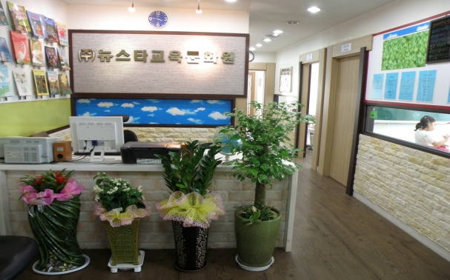

7

